TO: Dr. Bommer

FROM: Drillcorp (Eddy Aviles, Michael Callahan, Michael Nguyen, Tyler Spoede, Anastasia Valens)

DATE: May 2, 2011

SUBJECT: Petroleum Engineering and Design Final Report

**Summary of recommendations**

* Drill Well I-1 horizontally to avoid surface obstruction
* Use Rig No. 10 from Pioneer Drilling South Texas fleet
* Drill wells with three casing sections, using water based mud for entire hole
* Use 2 3/8” tubing inside 4 1/2” production casing (set to TD of 8850 ft), 9 5/8” intermediate casing (set to 5500 ft), and 13 3/8” surface casing (set to 1600 ft)
* Use class A cement to cement entire surface casing string, and class H cement to cement 1000 feet of intermediate string and 500 feet of production string
* Complete all wells with a single completion (unlike dual completion originally used in Wells I-2 and I-3). Perforate smaller interval of sands in F5B reservoir to delay water and gas production
* Estimates of oil in place in the F3 sand range from 700 MSTB to 1,100 MSTB, and in the F5B range from 1,300 MSTB to 1,600 MSTB, with a roughly 1,200 MMSCF gas cap
* Artificially lift Well I-3 to test feasibility of artificial lift throughout reservoir
* Convert Well I-4 to injection and inject produced water into F3 reservoir
* Facilities are designed to handle full production, including sale of oil and gas and reinjection of produced water
* Expected NPV of the project is roughly $41 million, and the project meets all company requirements

**Team member contributions:**

* Eddy Aviles
  + Permitting / Environment
  + Directional drilling, BHA, bit hydraulics
  + Production trend analysis
* Michael Callahan
  + Production tubing sizing (VLP/IPR)
  + Drilling Mud
  + Material Balance
  + Project Economics
* Michael Nguyen
  + Casing strengths / casing selection
  + Well log analysis
  + Volumetric analysis
* Tyler Spoede
  + Mud window / casing set depths
  + Casing sizing / bit selection
  + Cement
  + Facilities
* Anastasia Valens
  + Drilling rig selection
  + Well I-1 AFE
  + Well log analysis
  + Volumetric analysis

**TABLE OF CONTENTS**

|  |  |
| --- | --- |
| Introduction | 4 |
| 1. Geology | 4 |
| 2. Drilling Completions | 4 |
| Wellbore Architecture | 4 |
| Mud Window | 5 |
| Tubing Sizing (VLP/IPR) | 10 |
| Casing Depths and Sizes | 11 |
| Casing Design | 13 |
| Cement | 20 |
| Bits | 21 |
| Hydraulics | 21 |
| Directional Drilling | 22 |
| Bottom Hole Assembly | 23 |
| Drilling Mud | 23 |
| Drilling Rig | 25 |
| Completions | 28 |
| 3. Permitting / Environmental Considerations | 28 |
| 4. Hydrocarbons in Place | 31 |
| Volumetrics | 31 |
| Volumetric Mapping | 36 |
| Material Balance | 44 |
| Combined Analysis | 47 |
| 5. Production Analysis | 48 |
| 6. Reservoir Analysis | 51 |
| F3 Reservoir | 51 |
| F5B Reservoir | 52 |
| F4 and F5D Reservoirs | 52 |
| Enhanced Recovery | 52 |
| 7. Facilities | 52 |
| 8. Economics | 61 |
| Well I-1 | 61 |
| Overall Project Economics | 64 |
| References | 67 |

**INTRODUCTION**

This project involved the development of an onshore Texas prospect. The first task was to design a drilling plan for the first exploration well, Well I-1. This included everything from the drilling and completion design, to production forecasting and economic analysis. After the completion of Well I-1, subsequent wells were drilled to develop the field. The second part of the project included analyzing the PVT, pressure, and production data from these wells, developing volumetric and recovery estimates using multiple methods, designing facilities, and preparing and economic forecast for the field, amongst other tasks. This report provides a detailed discussion of the tasks performed and the results obtained in the completion of this project.

**1. GEOLOGY**

This field is producing out of four different sands (F3, F4, F5B, and F5D) in the Frio reservoir. According to our geologic and geophysics department, our trap is a 3-way up-thrown closure against a large fault. Structure maps showing the location of this fault relative to our wells, as well as our estimated fluid contacts in the F3 and F5B, are shown in Figures 4.3 and 4.5. Prior to drilling of the first well, a bright spot anomaly on 3-D seismic indicated the potential for gas in the F5B sand. Development of the field has since determined that we have oil in the F3 and F5D sands, gas in the F4, and oil with a gas cap in the F5B.

The Frio is a fairly consolidated sandstone reservoir, with intermittent shale streaks. There is relatively high overall porosity, upwards of 30% in some areas, but the sand porosity can be significantly less in areas with large shale concentrations. A more detailed discussion of porosity and fluid saturations for each sand is included in the volumetric analysis section.

**2. DRILLING / COMPLETIONS**

The drilling and completions practices outlined in this section detail what was done for Well I-1. The same practices were then applied to each subsequent well in the field.

**Well Bore Architecture**

After the location of the well on the earth’s surface and the total expected depth have been determined, the next step in planning the well bore architecture is to look at the types of rock to be drilled. Some rocks are more stable than others and require little help in maintaining well bore stability. Others, however, are more susceptible to sloughing off into the well bore while the well is being drilled, and some rocks are more prone to fracturing than others. Most wells are not drilled open hole because different rock layers have differing fluids in them and need to be sealed to prevent communication inside the well. To prevent the well from caving in and to seal off differing layers, steel casing is set in the well and cemented. The casing is set at casing points. The depths of the casing points are determined by a few factors. In the shallower sections of the hole the well won’t be able to handle the more dense fluid that is required deeper in the well. Other sections of the hole might have reactive shale layers that need to be sealed off to prevent fracturing. In general, however, the casing points are determined by the mud window. The density of the mud is what keeps the well stable. The mud must be dense enough to prevent the fluids in the rock from flowing into the well. The mud must also be light enough to prevent fracturing the rock. The acceptable range of weight that the mud can be is known as the mud window.

**Mud Window**

To determine the mud window two things are needed. One is the pore pressure as a function of depth, and the other is the fracture gradient as a function of depth. The casing must be set to a point where the more dense mud would fracture the shallower rock. An example mud window is shown below in Figure 1.1.



**Figure 1.1**: Example mud window (Bommer 2009)

While drilling a well the pore pressure in the rock being drilled increases with depth. A normal pore pressure gradient is about .465 psi/ft which is assumes a continuous column of saline water. If this gradient were constant calculating the pore pressure would be easy, but there are over pressure zones where the pore pressure increases. These zones usually occur in shale layers. To detect these over pressure zones drilling data can be used. An increase in penetration rate, background gas increase, drilled cuttings shape changes to large splinters, and a flow line temperature change are all indicators of drilling into an over pressure zone. Other data that can be used to predict pore pressure include resistivity and sonic logs. In the geological prognosis that we were given, other fault blocks in the Frio have been found to be geo-pressured or over pressured. This could be attributed to the consolidated sand series being interlaced with shale streaks. There were no known depleted Miocene sands in our fault block so an under pressure scenarios were unlikely. To help predict the pore pressure, seismic interval transit time data was given to us. This data is seen in Figure 1.2 below. In a normal pore pressure regime, compaction causes the sonic transit time to decrease or get faster. This can be observed in Figure 1.2 from depths of 1500 feet to 5500 feet. In an over pressured region this trend is reversed and the sonic transit time increases, or gets slower. This is seen in Figure 1.2 from depths of 5500 feet to 6000 feet.

**Figure 1.2:** Sonic transit time vs. depth for nearby area

To calculate the pore pressure using sonic transit time we used Equation 1.01.

 (1.01)

$∆t_{n}$ = normal sonic transit time

$∆t$ = measured sonic transit time

To calculate the fracture pressure as a function of depth we used Eaton’s Correlation, shown in Equation 1.02.

$σ_{frac}=σ_{Hmin}=\frac{v}{1-v}\left(σ_{ob}-p_{p}\right)+p_{p}$ (1.02)



The overburden pressure was calculated using Equation 1.03 and Poisson’s Ration using Equation 1.04.

$σ_{ob}=0.433γ_{sw}D_{sw}+0.433γ_{g}D_{s}-2088.6\left(γ_{g}-γ_{f}\right)(1-e^{-0.000085D_{s}})$ (1.03)



$v=0.18≤\frac{ln⁡(\frac{D_{s}}{19.219})}{13.766}≤0.5$ (1.04)



Using the sonic transit time data and the equations for pore pressure and fracture pressure we came up with initial pore pressure and fracture pressures for a few depths shown in Table 1.1.

**Table 1.1**: Mud weight window calculation from sonic transit time

|  |  |  |  |  |  |  |  |  |  |
| --- | --- | --- | --- | --- | --- | --- | --- | --- | --- |
| Depth (ft) | Synthetic | Normal | Overburden | C | Pore Pressure | Mud Weight | Poisson's | Fracture | Mud Weight |
|  | Transit Time | Transit Time | (psi) |  | (psi) | lb/gal | Ratio | (psi) | lb/gal |
|  | (microsec/ft) | (microsec/ft) |  |  |  | w/ .5ppg trip |  | w/ .5 ppg kick | w/ .5ppg kick |
|  |  |  |  |  |  | margin |  | margin | margin |
|  |  |  |  |  |  |  |  |  |  |
| 1650.00 | 102.20 | 108.70 | 1465.87 | 1.20 | 625.29 | 7.79 | 0.32 | 1027.17 | 11.48 |
| 1875.00 | 111.50 | 108.25 | 1670.34 | 0.92 | 939.68 | 10.14 | 0.33 | 1304.03 | 12.88 |
| 1956.00 | 106.30 | 108.09 | 1744.21 | 1.05 | 866.71 | 9.02 | 0.34 | 1310.37 | 12.39 |
| 2018.00 | 111.50 | 107.96 | 1800.84 | 0.91 | 1017.85 | 10.20 | 0.34 | 1417.76 | 13.02 |
| 2098.00 | 106.30 | 107.80 | 1874.02 | 1.04 | 936.89 | 9.09 | 0.34 | 1421.60 | 12.54 |
| 2120.00 | 104.20 | 107.76 | 1894.17 | 1.11 | 889.48 | 8.57 | 0.34 | 1410.88 | 12.30 |
| 2165.00 | 114.60 | 107.67 | 1935.41 | 0.83 | 1165.22 | 10.85 | 0.34 | 1567.64 | 13.43 |
| 2194.00 | 108.80 | 107.61 | 1962.01 | 0.97 | 1050.73 | 9.71 | 0.34 | 1528.92 | 12.91 |
| 2223.00 | 114.60 | 107.55 | 1988.63 | 0.83 | 1199.23 | 10.88 | 0.35 | 1615.21 | 13.48 |
| 2270.00 | 106.30 | 107.46 | 2031.80 | 1.03 | 1023.24 | 9.17 | 0.35 | 1558.30 | 12.71 |
| 2355.00 | 105.00 | 107.29 | 2109.99 | 1.07 | 1027.21 | 8.89 | 0.35 | 1608.44 | 12.64 |
| 2398.00 | 111.50 | 107.20 | 2149.60 | 0.89 | 1230.10 | 10.37 | 0.35 | 1726.55 | 13.35 |
| 2415.00 | 114.60 | 107.17 | 2165.27 | 0.82 | 1312.84 | 10.96 | 0.35 | 1774.11 | 13.63 |
| 2550.00 | 104.20 | 106.90 | 2289.90 | 1.08 | 1097.68 | 8.78 | 0.36 | 1754.08 | 12.73 |
| 2641.00 | 108.80 | 106.72 | 2374.11 | 0.94 | 1292.61 | 9.92 | 0.36 | 1894.70 | 13.30 |
| 2687.00 | 103.00 | 106.63 | 2416.74 | 1.11 | 1121.78 | 8.53 | 0.36 | 1846.65 | 12.72 |
| 2742.00 | 108.80 | 106.52 | 2467.76 | 0.94 | 1348.58 | 9.96 | 0.36 | 1979.07 | 13.39 |
| 2844.00 | 102.20 | 106.31 | 2562.54 | 1.13 | 1166.67 | 8.39 | 0.36 | 1962.12 | 12.77 |

The resulting mud window using a .5 lb/gal kick and trip margin is shown in Figure 1.3. The 0.5 lb/gal trip margin is added to the mud weight used to hold back the pore pressure to avoid taking a kick while the pipe is out of the hole. The weight of the pipe normally helps to hold back the pore pressure. The 0.5 lb/gal kick margin is subtracted from the mud weight used to avoid fracturing the rock. This essentially makes the mud window narrower, adding a safety factor. According to this mud window the heaviest weight mud we would use is approximately 15lb/gal. Looking at local drilling data, the maximum mud weight used was 13lb/gal, meaning that the mud window we came up with was a little on the heavy side. This was due to using 3 for the calculation of C in Equation 1.01. Using a value of 1.5 we came up with an adjusted mud window shown in Figure 1.4. Looking at this mud window a 13lb/gal mud can be used in the deepest part of the well, similar to local data. Looking at the revised mud window we determined that we will drill the well using conductor casing, surface casing, intermediate casing, and production casing, using mud weights of 10.5 lb/gal and 13 lb/gal. According to the mud window it might have been possible to drill the well without an intermediate casing.

**Figure 1.3**: Initial mud window based on sonic transit time (C=3)

**Figure 1.4**: Adjusted mud window with C =1.5 (similar to local area wells)

We decided against this because this was our first well and the severity of the over pressure was still somewhat uncertain. After drilling this first well we can decide whether or not it is feasible. Eliminating the intermediate casing could save money.

**Tubing Sizing (VLP/IPR)**

In order to correctly size the production tubing in Well I-1, production data from nearby wells had to be analyzed to develop a predicted inflow performance ratio (IPR) for our well. Because we anticipated a gas well, we used a nearby well with high gas production to ensure our tubing selection was large enough to accommodate a large gas rate. Using two well tests from this well, the slope of the pressure vs. flow rate line was found to be -1.53 psi/MCF/day (see Figure 1.5 below). This slope was used to project an IPR curve for our well, with the intercept set to our estimated reservoir pressure (Pe), roughly 5300 psi. The IPR curve gives a prediction of the flow rate possible (MCF/day) at given values of flowing well pressure (Pwf).

In conjunction with our projected IPR curve, we created vertical lift performance (VLP) curves for multiple common tubing sizes. The intersection of these VLP curves with the IPR curve represents the maximum flow rate that each tubing size could support in our well. As seen in Figure 1.5, there is very little difference in the performance of the three tubing sizes analyzed; therefore, we decided to use the smallest of the three sizes, 2 3/8”.

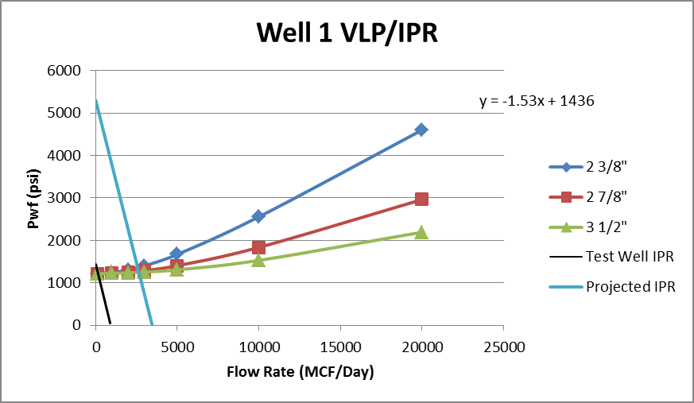

**Figure 1.5**: VLP/IPR curves for Well I-1

**Casing Depths and Sizes**

Casing sizes are determined by the size of the production tubing. Once the production tubing size is set the rest of the casing sizes can be calculated. The size of the hole must be large enough to reduce the chance stuck casing. It should also be big enough to allow for a thick enough cement sheath. The sheath is important because it creates a seal between the rock layers. The inside of the casing must be large enough to pass the bit of the next hole section through. Fishing clearances should also be taken in to account in the event of lost tools down hole. A general rule of thumb is to have about one inch of clearance around the collar of the casing for a good cement seal. To calculate the fishing clearances we used Equation 1.05.

$0.13≤\frac{C}{D_{f}}≤0.18$ (1.05)

$C=\frac{D_{o}-D_{f}}{2}$ (1.06)



Using Equation 1.06 we calculated the casing sizes for the conductor, surface, intermediate, and production casing for a 2 3/8” production tubing. The sizes are shown in Table 1.2.

**Table 1.2:** Casing sizes based on 2 3/8” production tubing

|  |  |  |  |  |
| --- | --- | --- | --- | --- |
|  | Conductor Casing | Surface Casing | Intermediate Casing | Production Casing |
| Fishing Clearance Ratio |  |  | 0.14 | 0.14 |
| Drill Collar O.D |  |  | 6.75" | 3.00" |
| Do |  |  | 8.64" | 3.84" |
| Casing Size | 18 5/8" O.D. | 13 3/8" O.D. | 9 5/8" O.D. | 4 1/2" O.D. |

Once the casing sizes were determined the hole size and bit size could be calculated. From Table 7.7 in Bourgoyne Jr. et al. (1991), the bit sizes were selected and are shown in Table 1.3.

**Table 1.3**: Bit sizes for the surface, intermediate, and production hole

|  |  |  |  |
| --- | --- | --- | --- |
|  | Surface Hole | Intermediate Hole | Production Hole |
| Bit Size | 17 1/2" | 12 1/4" | 6 1/4" |

The conductor casing is hammered into the ground until the point of first refusal. The surface casing must be set deep enough to seal off fresh water zones and is usually set deeper than 1000 feet. This is because if the well is shut in and builds enough pressure, the shallow rock could fracture allowing fluids to flow outside of the casing. We chose to set our surface casing to a depth of 1600 feet. This will ensure that we will be able to contain any abnormally high pressure zones while drilling the bottom part of the well, and should seal off any fresh water zones. The depth of the intermediate casing was determined from the mud window. We expect an over pressure zone to occur around 5500 feet. To protect the upper part of the well from fracturing due to the higher mud weight needed to control the over pressure zone, we decided to set casing at 5500 feet. This will allow us to drill the bottom part of the well while not fracturing the rock above. The production casing was set to our target depth of 8850 feet. The well schematic is shown in Figure 1.6.

|  |  |  |  |  |  |  |  |  |  |
| --- | --- | --- | --- | --- | --- | --- | --- | --- | --- |
|  |  |  |  |  |  |  |  |  |  |
| 0 ft | |  | | --- | |  | |  |  |  |  | 18 5/8" Conductor Casing | | |  |
|  |  |  |  |  |  |  |  |  |  |
|  |  |  |  |  |  | 13 3/8" O.D Surface Casing | | |  |
|  |  |  |  |  |  |  |  |  |  |
|  |  |  |  |  |  |  |  |  |  |
|  |  |  |  |  |  |  |  |  |  |
|  |  |  |  |  |  |  |  |  |  |
|  |  |  |  |  |  |  |  |  |  |
|  |  |  |  |  |  |  |  |  |  |
|  |  |  |  |  |  |  |  |  |  |
|  |  |  |  |  |  | 9 5/8" O.D Intermediate Casing @ 5500' | | | |
|  |  |  |  |  |  |  |  |  |  |
|  |  |  |  |  |  |  |  |  |  |
| 5500 ft |  |  |  |  |  |  |  |  |  |
|  |  |  |  |  |  |  |  |  |  |
|  |  |  |  |  |  |  |  |  |  |
|  |  |  |  |  |  |  |  |  |  |
|  |  |  |  |  |  | 4 1/2" O.D Production Casing @ 8850' | | | |
|  |  |  |  |  |  |  |  |  |  |
|  |  |  |  |  |  |  |  |  |  |
|  |  |  |  |  |  |  |  |  |  |
| 8850 ft |  |  |  |  |  | 2 3/8" Production Tubing @ 8850' | | | |

**Figure 1.6**: Wellbore schematic

**Casing Design**

We selected our casing set depths using the mud window. As described above, we selected 1600 feet for our surface casing set depth. We chose 5500 ft, near the start of the pressure transition zone, as our depth for intermediate casing. The production casing is run to our total depth of roughly 8800 ft. Once our casing diameters were determined, we needed to select the weight, grade, and couplings for each string.

SAFTEY FACTORS

Safety factors are used to increase the required properties of a tube. They are intended to account for any unknown circumstances that may increase stress on a pipe. The safety factor for casing collapse was determined to be 1.125. For tensile design, we used a safety factor of 1.8, which compensates for the potential overpull when pulling stuck pipe. We used 1.0 as the safety factor for casing burst. From the stress/strain curve for burst (Figure 1.7), there is extra expandable casing (up to point C) after the elastic/plastic limit (point B). The minimum yield strength of the tubing was less than the failure strength so therefore a safety factor was not necessary.

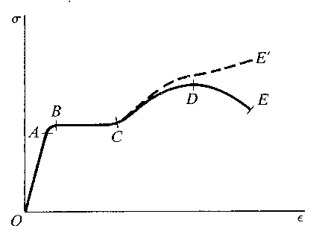

**Figure 1.7**: Properties of Materials (Bommer 2009)

CASING COLLAPSE

This worst case scenario happens during drilling where the inside of the tube becomes empty due to severe lost circulation. Collapse occurs when the external pressure exceeds the collapse resistance of the casing. To find the collapse load for a casing, we used the following equation:

$p_{c}=SF\left(.052\right)p_{m}*D$ (1.07)

$p_{c}$ = Collapse pressure (psi)

$SF$ = Safety factor (1.125)

$p_{m}$ = Mud density

D = Depth of casing (ft)

CASING BURST

In the worst case scenario for burst during drilling, the casing is filled with gas with a high enough pressure to fracture the rock at the casing shoe. This is most likely to occur during blow outs when the blow out preventer has been shut. The internal differential pressure exceeds the burst resistance which leads to casing burst. To find the burst load for a casing, we used the following equation:

At depth:

$p_{b@depth}=D(MW*.052-.433)$ (1.08)

$p_{b@depth}$ = Burst pressure at casing depth (psi)

$MW$ = Mud weight (lbs/gal)

At surface:

$p_{b}=D(MW*.052)$ (1.09)

$p_{b}$ = burst pressure at surface

$MW$ = mud weight (lbs/gal)

CASING IN TENSION

The worst case scenario for casing in tension happens when the casing string becomes stuck at the bottom of the hole requiring a force to be applied at the surface to try to pull the string free. To find the tensile load for a casing, we used the following equation:

$F_{t}=SF\left(w_{c}\right)D$ (1.10)

$F_{t}$ = tensile load (lbf)

= overpull or safety factor

$w_{c}$ = air weight per foot for casing (lbf/ft)

D = depth (ft)

SURFACE CASING

For Collapse Load:

Using Equation (1.07) to calculate collapse load, we found the collapse pressure to be 935.7 psi. The pressure for collapse at the surface is 0 so we made a line from the collapse pressure at the surface to the calculated pressure at the casing depth as seen in the blue line in Figure 1.8 below.

**Figure 1.8**: Surface casing collapse load

For Burst Load:

Using Equation (1.09) to calculate burst pressure, we found the pressure at the shoe of the surface casing to be 139.2 psi and at the surface to be 832 psi. This gave us a linear line between the two values as seen in the blue line in Figure 1.9 below.

**Figure 1.9**: Surface casing burst load

For Tensile Load:

Using Equation 1.10 to calculate tensile load, we found the tensile load at the surface to be 156,960 lbs. The tensile load at the casing depth was 0 so again we connected the two points with a line as seen in Figure 1.10 below.

**Figure 1.10**: Surface casing tensile load

We performed the same calculations/routine for the intermediate and production casings.

INTERMEDIATE CASING

For Collapse Load:

The collapse pressure was calculated at 3216.3 psi using Equation (1.07).

**Figure 1.11**: Intermediate casing collapse load

For Burst Load:

The burst pressure at the surface was calculated at 2860 psi using equation 1.09 and the pressure at the intermediate casing depth of 5500 ft was 478.5 psi.

**Figure 1.12**: Intermediate casing burst load

For Tensile Load:

The tensile strength was calculated to be 396,000 lbs using equation 1.10.

**Figure 1.13**: Intermediate casing tensile load

PRODUCTION CASING

For Collapse Load:

The collapse pressure was calculated at 6792.8 psi using equation 1.07. Using 0 psi at the surface, we created the blue line shown in Figure 1.14 below.

**Figure 1.14**: Production tubing collapse load

For Burst Load:

The burst pressure at the surface was calculated at 6040.3 psi using equation 1.09 and the pressure at the intermediate casing depth of 5500 ft was 2229.9 psi. These two values created the blue line shown below.

**Figure 1.15**: Production casing burst load

For Tensile Load:

The tensile strength was calculated to be 183,744 lbs using equation 1.10.

**Figure 1.16**: Production casing tensile load

TUBING SELECTION AND METALLURGY

After calculating the collapse pressure, burst pressure, and tensile loads, the weight, grades, and couplings for the strings had to be chosen from the values. After finding the outside diameters of the three casings, we used Table 7.6 from Bourgoyne Jr. et al. (1991) to choose the right grades. The pipe we chose had to satisfy all three loads for each casing. Our goal was to satisfy those requirements while also being cost effective. For the surface casing, the OD was 13 3/8”. We chose the short thread and collar because that was the only option for a coupling. For the production casing with a 4 ½” outside diameter, we did something different. The body strength of the tubing was 300,000 lbs and long thread and collar (LTC) joint strength was 233,000 lbs. From Figure 1.16 you can see that for the worst case scenario using the LTC joint strength of 223,000 lbs, it still satisfied the calculated tensile load of 183,744 lbs for the production casing. For the intermediate casing, we also chose the LTC couplings, as it also satisfied all three calculated loads for burst, collapse, and tensile. After finding the grades, looking at couplings, and meeting our requirements, we selected tubing for the surface, intermediate, and production casings as shown in the Table 1.4

**Table 1.4**: Casing details

|  |  |
| --- | --- |
| **Surface Casing** | 13.375", 54.5 lbm/ft, J-55, STC |
| **Intermediate** | 9.625", 40 lbm/ft, C-90, LTC |
| **Production** | 4.5", 11.60 lbm/ft, C-90, LTC |

**Cement**

The purpose of cementing is to support and protect the casing, to seal the annulus between the casing and the open hole, to plug and abandon wells, and to seal zones to prevent communication. The cement must have enough compressive strength to resist failure due to pore pressure and tensile strength to resist failure in tension due to cyclical loading caused by temperature fluctuations. To gain an idea of the magnitude of the pore pressure, we looked at the mud window. To get a more exact pore pressure estimate, pore pressure measurements can be made while drilling. Near the surface of the well the density of the cement is great enough to fracture the rock. To reduce this, light weight cement should be used. We chose to use a Class A cement with 2% bentonite. The bentonite reduces the density of the cement slurry. An unfortunate side effect of the bentonite is that it also reduces the 24-hour compressive strength of the cement. Since we will only be using the Class A cement in the upper-most part of the well, the pore pressure isn’t great enough to crush the cement. In the rest of the well we decided to use premium class H cement since it cost the same as other cements and has a greater 24-hour compressive strength. By law we have to cement the entire surface casing. Even though we are using light weight cement we still expect to fracture the rocks. To account for this we will include an 80% excess in our volume calculations. The intermediate casing will be cemented 1000 feet above the shoe of the intermediate casing. This will prevent any fluids from escaping around the shoe of the casing. The production casing will be cemented from the bottom of the hole to 500 feet above the shoe of the intermediate casing. This will seal off the entire productive zone. To calculate the volume of cement needed we used Equation 1.11.

$Volume=\frac{π}{4}\left(O.D^{2}-I.D^{2}\right)*H$ (1.11)

Volume = cubic feet

O.D = Diameter of hole (ft)

I.D = Outside Diameter of Casing (ft)

H = Height (ft)

To find the volume in sacks of cement, the volume in cubic feet was divided by the yield per sack. The 24-hour compressive strengths of cement are dependent on temperature. Generally, as temperature increases, the 24-hour compressive strength increases. Table 1.5 summarizes the volumes needed and the compressive strengths.

**Table 1.5**: Summary of Cement volumes and compressive strengths

|  |  |  |  |  |  |  |  |
| --- | --- | --- | --- | --- | --- | --- | --- |
| Interval | Cement Type | Density | Yield | Excess | Volume | Volume | Compressive Strength |
| (ft) |  | (ppg) | (cuft/sack | (%) | (cuft) | (sacks) | 24 hour psi |
| 0-1600 | Class A 2% Bentonite | 14.7 | 1.36 | 80 | 2002 | 1472 | 615-2187 |
| 4500-5500 | Class H | 16.4 | 1.06 | 15 | 361 | 341 | 5500-5900 |
| 5000-5500 | Class H | 16.4 | 1.06 | 0 | 17 | 16 | 5900-6260 |
| 5500-8800 | Class H | 16.4 | 1.06 | 15 | 126 | 119 | 6260-8400 |

**Bits**

For the surface hole we were limited to a Security DBS type XSC1 roller cone bit. The bit has a journal bearing and with an expected penetration rate of 100ft/rotating hour this section of hole should be drilled in 16 hours. The expected bearing life is 60 hours, so the bit should last the entire time drilling the surface hole. We will be doing our directional drilling in the intermediate hole. Since we have a top drive we decided to go with the Security DBS type FM2563 PDC bit. There is no limit on rotating hours as long as the cutters stay intact so we expect this bit to last the duration. The production hole will be drilled with the Security DBS type XSC1S roller cone bit. The expected penetration rate is 75 ft/rotating hour. This section of hole should take 45 rotating hours to drill and comes under the 60 bearing life limit. The summary of our bit selection is shown in Table 1.6.

**Table 1.6**: Summary of bits

|  |  |  |  |
| --- | --- | --- | --- |
|  | Surface Hole | Intermediate Hole | Production Hole |
| Bit Size | 17 1/2" | 12 1/4" | 6 1/4" |
| Bit Type | Roller Cone | PDC | Roller Cone |
| Penetration Rate (ft/hr) | 100 | 75 | 75 |
| Bearing Life (hr) | 60 | No limit | 60 |
| Hours to Drill Section (hr) | 16 | 52 | 45 |
| Number of Nozzle Ports | 3 | 5 | 3 |
| Cost ($) | 13125 | 36750 | 9375 |

**Hydraulics**

To incorporate our hydraulics concerns for our well we used the REEDHycalog program to input our calculated data (measured depth, plastic viscosity, yield point, casing diameters, drill pipe, etc.) and view its theoretical performance. Our main objective we hoped to see when we ran the program was for the green line to be maximized (Figure 1.17). This means that the green line passes through the blue curve at its maximum point. Another objective we hoped to accomplish was to get a positive cuttings slip velocity. Our cuttings slip velocity was estimated to be 46.49 ft/min. This number needs to be positive in order to show that cuttings will flow up the hole and not obstruct drilling. Figure 1.17 shows our hydraulics optimization bit run report for our surface casing. Our intermediate and production casing were also done in such fashion with similar results.

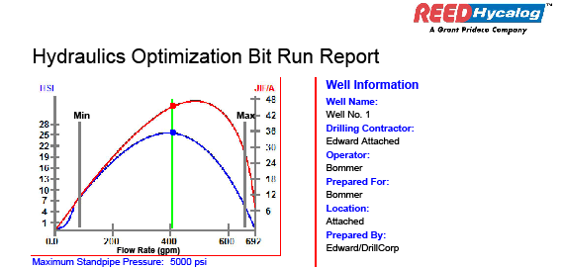

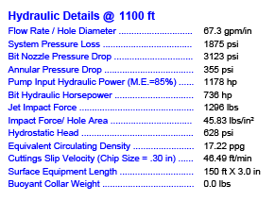

**Figure 1.17**: Bit hydraulics optimization report for surface hole

**Directional Drilling**

Our company faced the issue that a rice water canal runs right through our desired drill spot. Therefore, to avoid this canal, we decided to move our entire 40 acre pad 100 feet north. This required the use of directional drilling to hit our target reservoir at total depth. We determined that our intermediate drill string would be the best point at which to do this because it is the longest section of hole and would give the most leeway, and because we intended to use a top drive in this section regardless and it would be more efficient to use it for a dual purpose. Using simple trigonometry (100 ft horizontal in a 3900 ft deep section of hole), our angle of drilling was calculated to be 1.30195 degrees due south to hit our depth and target spot.

**Bottom Hole Assembly**

Our well is using a BHA that uses a top drive motor to enhance the speed on the bit. Ordinarily in a directionally drilled well the BHA would have to be different in order to reduce excess drag on the pipe as the depth increases. However, our well is only going to be drilled directionally at an angle of 1.30195 degrees. The larger the inclination and thus degree of directional drilling the more drag or resistance to the pipe is implemented.

N = Fsinα (1.12)





**Figure 1.18:** Forces acting on directional assembly

This is good news for our directional drilling project because with an angle so minute, we can almost ignore this drag problem altogether. Drag increases with depth because as more pipe is added on, more force is applied to the pipe, and more drag is put on the drill collars. Therefore it is better to have smaller surface area drill collars as to minimize this problem. This would ordinarily become an issue, but again, this problem is negligible due to our small directional drilling angle. Torque is also another issue prevalent in directional drilling endeavors. This is the resistance to pipe rotation in the hole as it is being drilled. This is important because the drill string has a torque limit that if reached can burst the pipe. To limit bottom torque it gives more torque available for drilling. As well as with drag, torque can be predicted. Any deviations or problems during drilling usually means that the hole needs cleaning (drill bits).

**Drilling Mud**

The following discussion is of the mud selection for Well I-1. We assume that similar mud specifications will be used for subsequent wells in the field.

Based on nearby well drilling time curves, we expect to be able to drill and case the bottom section of our hole (~3300 ft), containing the Annowack Shale, in under seven days. Therefore, according to our mud expert, water based mud should be suitable for the entire hole. Our mud weights were determined from the calculated mud window (Figure 1.4), and specified ranges of various mud properties are given based on data from Bourgoyne Jr. et al. (1991). A summary of recommended mud weights and properties are listed below for each section of the hole.

***Surface Hole:*** 10 ppg water based mud

Properties:

* Maximum solids volume fraction: 15%
* Plastic viscosity range: 6-16 CP @120°F
* Yield point range: 3-26 lbf/100 ft2

***Intermediate Hole:*** 11ppg water based mud

Properties:

* Maximum solids volume fraction: 20%
* Plastic viscosity range: 8-18 CP @120°F
* Yield point range: 4-23 lbf/100 ft2

***Production Hole:*** 13 ppg water based mud

Properties:

* Maximum solids volume fraction: 35%
* Plastic viscosity range: 12-26 CP @120°F
* Yield point range: 5-18 lbf/100 ft2

***Filtration Control***

Filtration control should not be needed in the surface or intermediate holes because we are not concerned with damage to these formations. The only reason we may have to use filtration control in these sections is if we see abnormally thick or soft mudcake. We will likely need to use a filtration control additive in the production hole to avoid damaging our reservoir. Maintaining the mud with an API water loss no greater than 15 ml should adequately avoid problems with stuck pipe and/or formation damage.

***Mud Volume***

Our mud volumes are designed to completely fill our two 800 bbl mud tanks at the maximum expected mud weight of 13 ppg. The equations used to calculate the mud volume at each mud weight and the amount of barite needed to increase the mud weight at each step are shown below (Bourgoyne Jr. et al, 1991).

$V_{2}=V_{1}\frac{(ρ_{b}-ρ_{2})}{(ρ_{b}-ρ_{1})}$ (1.13)

(1.14)

V2 = Final mud volume after addition of barite

ρ2 = Density of mud after addition of barite

V1 = Initial mud volume before addition of barite

ρ1 = Density of mud before addition of barite

ρb = Density of API barite (35.0 lbm/gal)

mb = Mass of barite added

The results are summarized in Table 1.7.

**Table 1.7**: Mud volumes and total barite added for each section of hole

|  |  |  |  |
| --- | --- | --- | --- |
| Section | Mud Weight (ppg) | Total Mud Volume (bbls) | Barite Added (lbm) |
| Surface | 10 | 1408 | N/A |
| Intermediate | 11 | 1467 | 86,240 |
| Production | 13 | 1600 | 196,000 (additional) |

**Drilling Rig**

We selected drilling rig No. 10 from the South Texas Division of Pioneer Drilling Co. inventory. A key reason for this choice was that the rig has a top drive, which makes directional drilling easier than with the conventional rotary and kelly spinner. It also has a depth capability of 15000 ft, which more than satisfied our desired depth. The rig operates with a 1000 HP generator and uses 2 Skytop-Brewster B1300T mud pumps. The detailed specifications of this rig are included in Figure 1.19.

Equation 1.15 describes draw works engine (or motor) horsepower (Pi, HP). The engine or motor power is passed through a transmission to the draw works. Given a hook load, w, of 350 tons, we could determine the velocity of the blocks ($v_{b}$) in ft/min (Bommer 2009).

$P_{i}=\frac{W*v_{b} }{E (33,000)}$ (1.15)

$$1000 HP=\frac{350 ton*2000 \frac{lb}{ton}*v_{b} }{0.874 (33,000)}$$

$v_{b}=41.2 ft/min$.

Draw work calculations could be used to determine the loads on the legs, assuming that the blocks have 6 lines strung through (n=6) and the efficiency of the pulleys due to friction, E, is 0.874. Since the loads on the legs are not uniform, Leg A or dead line anchor supports 1/4th of the suspended load plus the dead line force. Leg B holds only ¼ of the suspended load. Leg C and D each takes ¼ of the suspended load and ½ of the fast line load. The derrick for Rig No.10 has the weight suspended from the blocks (W=250,000 lbf). The load for each leg is shown below (Bommer 2009):

$F_{A}=\frac{W}{4}+\frac{W}{n}=\frac{250,000}{4}+\frac{250,000}{6}=$ 104,167 lbf. (1.16)

$F_{B}=\frac{W}{4}=\frac{250,000}{4}=$ 62,500 lbf. (1.17)

$F_{C}{=F}_{D}=\frac{W}{4}+\frac{W}{2*E*n}=\frac{250,000}{4}+\frac{250,000}{2*0.874*6}=$ 86,336.8 lbf. (1.18)

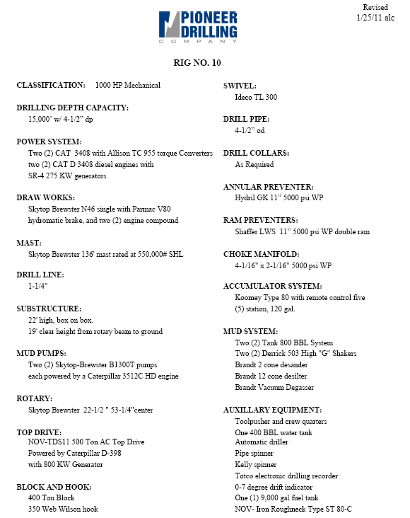

**Figure 1.19**: Drilling rig details

**Completions**

Because we have the benefit of knowing what was done to complete these wells, and the results of those decisions, we can take a look back and determine what was done well and what could have been improved.

DUAL COMPLETIONS

Wells I-2 and I-3 were dual completed to produce separately out of the F3 and F5B reservoirs. A likely reason for this was to allow each reservoir to flow at the production limit set by the state (600 bbl/day), as opposed to the combined production having to meet this requirement. However, with the benefit of hind-sight, we know that none of the wells ever had production this high, even with the two reservoirs combined. One benefit we do get from the dual completions is the ability to analyze the production from each reservoir separately. However, because of the higher cost of dual completions, it would probably have been more cost effective not to use them.

PERFORATIONS

These wells were completed by perforating the entire sand interval. While this does open the largest area of wellbore open to flow, it can present problems, particularly in the F5B. The perforations near the top of the sand will be the first to produce the gas cap as it expands, and the perforations at the bottom will be the first to produce water as the aquifer expands. When the wells were originally completed, it was not known that the F5B would be an oil reservoir, which is the likely reason for perforating over the entire sand. Knowing that it is an oil reservoir, we would likely be more selective and only perforate the middle section of the sand, allowing us to produce more oil before the gas cap or aquifer expanded to the perforations. Not producing the gas would also help to maintain the pressure in the reservoir longer, helping to continue driving the oil.

One final note to make with regards to the original completions is that Well I-1 produced out of the gas cap for its first three months of production. Ideally this would not have been done, but because the reservoir was expected to be a gas reservoir and it was not realized that oil was present until later, this was not a mistake that could have been easily avoided. The gas production was shut in immediately after noticing the presence of oil, which is exactly what we would do if presented with the situation again.

**3. PERMITTING / ENVIRONMENTAL CONSIDERATIONS**

Permits are a necessary part of our industry. They insure that there is a sense of order and information for all parties in regards to a drill site. They also serve to protect owners and the environment from reckless drilling and design.

Determination of the Base of Usable Quality Water

The first permit we needed to have competed was the “Determination of the Base of Usable Quality Water”. This permit served to give us a reference to the water table in order to have cemented casing and protect it. With this permit submitted we were given the information that the usable base is 1600 ft. We then used this data to begin our drill string and casing design. A copy of this permit is shown in Figure 3.01 below.

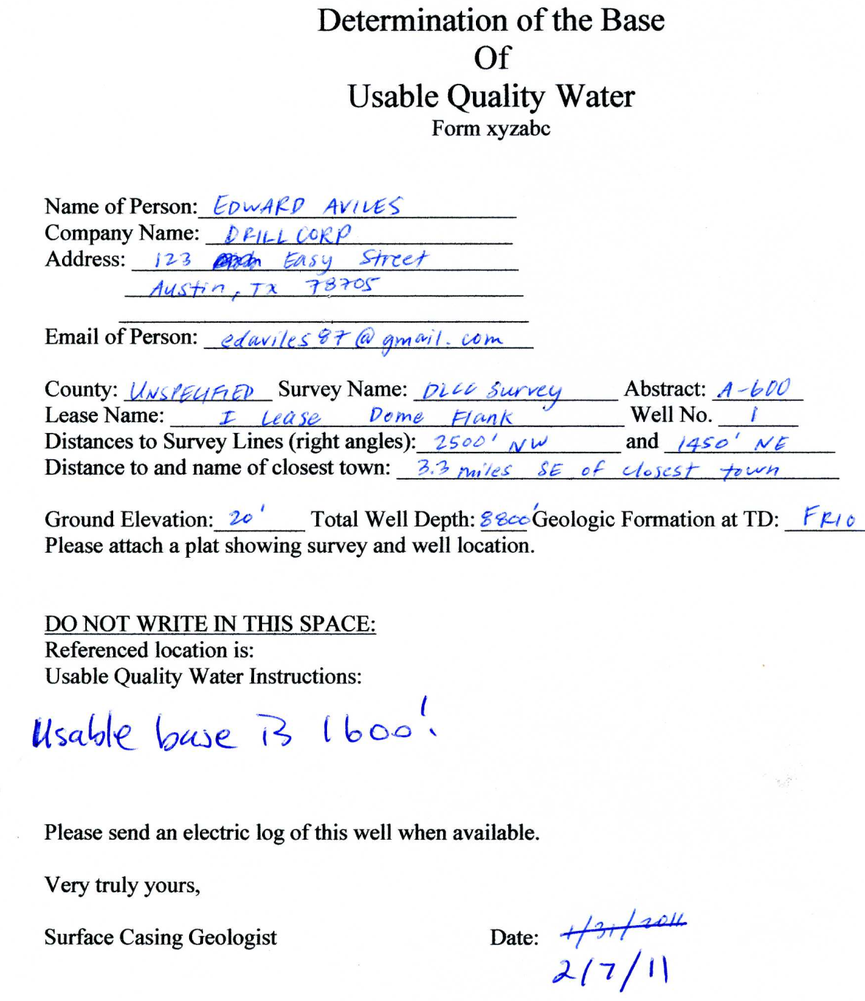

**Figure 3.01**: Usable water table permit

Request for Driveway Permit

Our company then had the task of designing a driveway that would be safe and under the regulations of the Texas Department of Transportation. Our road from the highway to our drill pad is approximately 1556 feet. Attached is our driveway design (Figure 3.02). We used crushed limestone as per our contractual agreement with the owner of the field. After diligent search of appropriate information we have included important data such as frontage road connection spacing, appropriate speed limit, and driveway pipe length requirements.

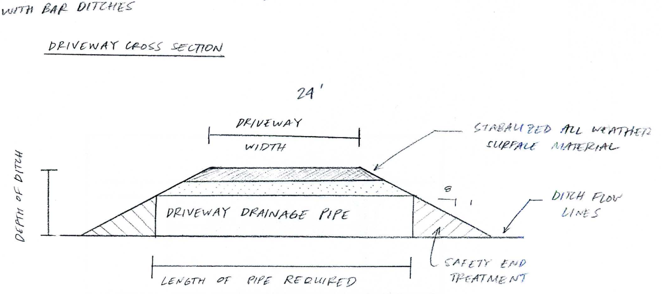

**Figure 3.02**: Driveway cross-section

Application for Permit to Drill, Recomplete or Re-Enter

Another permit required in order to drill is the W-1. Basically this form submits all required information that the Railroad Commission of Texas needs to be made aware of in order for them to issue a drilling permit number. A copy of the permit is shown in Figure 3.03.



**Figure 3.03**: Form W-1, Permit to Drill

**4. HYDROCARBONS IN PLACE**

We took two different approaches to calculating the volume of hydrocarbons in place in the F3 and F5B reservoirs. The volumetrics approach involved mapping our reservoirs, determining area and net pay of each, and using this information along with well log data to calculate volumes in place. The material balance uses PVT, pressure, and production data to calculate fluid volumes.

**Volumetrics**

LOG/CORE ANALYSIS

Determination of porosity distribution in a reservoir is usually preceded by porosity determination in well locations. In this procedure, we relied on both well-log data and core measurements. By reading the gamma-ray log, good sands with the potential to produce fluids could be differentiated by their gamma ray readings below the shale baseline. For each well, the neutron and density porosities are read directly from the neutron porosity (NPHI) and density porosity (DPHI) logs. A method to average the porosities ($∅$) utilizes Equation 4.01 where $∅_{n}$ and $∅_{d}$ are neutron and density porosity, respectively.

$∅=\sqrt{\frac{{(∅_{n})}^{2}+{(∅_{d})}^{2}}{2}}$ (4.01)

The neutron and density porosities (in porosity units) are improved by applying a shale correction that accounts for the effects of shales in the sand sections. The density-neutron calculation of the volumetric concentration of shale in a water-bearing sand is given by Equation 4.02.

$C_{sh}=\frac{∅_{n}-∅_{d}}{∅_{n,sh}-∅_{d,sh}}$ (4.02)

$C_{sh}$ is the volumetric concentration of shale, while $∅_{n,sh}$ is neutron (apparent) porosity of pure shale and $∅_{d,sh}$ is density (apparent) porosity of pure shale, both expressed in water-filled sandstone porosity units. Equations 4.03-4.05 explain density-neutron porosity corrections for shaly sands (case of dispersed shale).

$∅_{d}^{c}$ = $∅_{d}$- $C_{sh}$ $∅_{d,sh}$* (4.03)

$∅_{n}^{c}$ = $∅_{n}$- $C_{sh}$ $∅_{n,sh}$* (4.04)

$∅_{s}=\sqrt{\frac{{(∅_{n}^{c})}^{2}+{(∅_{d}^{c})}^{2}}{2}}$ (4.05)

$∅_{d}^{c}$ and $∅_{n}^{c}$ are shale-corrected density and neutron porosity expressed in water-filled sandstone porosity units; $∅_{s}$ is non-shale (sand) porosity.

The well logs contain Array Induction Image Tool (AIT-H) resistivity logs with different depths of investigation. We read the formation resistivity ($R_{t}$) from the log with the deepest investigation, approximately 90 inches. Equation 4.06 is Archie’s Law, which describes electrical resistivity of water-saturated sands.

$R_{t}=R_{w}\frac{a}{{(∅_{s})}^{m}}\frac{1}{{Sw}^{n}}$ (4.06)

Rt = Electrical resistivity of the fluid saturated rock (ohm-m)

Rw = Electrical resistivity of connate water (ohm-m)

m = Cementation exponent

n = Saturation exponent

a = Tortuosity effect

Most of the sands in our six wells are saturated with hydrocarbons, as indicated by the resistivity log deflecting to the right of its shale base line. A water-wet sand from each well is used as a reference in calculating the resistivity of water that occupies the pore space of the rock. The cleanest possible sand is chosen to reduce the effects of shale on our resistivity. The sand must also be completely saturated, allowing us to make the assumption that Sw = 1. Rewriting Equation 4.06 and substituting a=0.62, m=2.15, and n=2 (typical values for sandstones) gives us the following expression.

$R_{w}=R_{t}\frac{{(∅_{s})}^{2.15}}{0.62}$ (4.07)

Equation 4.07 determines the resistivity of connate water, allowing us to predict Archie water saturations since the formation resistivity for each depth is also known. Using the same values of a, m, and n, the water saturation (unitless) at a particular depth is given by

$S_{w}=\sqrt{\frac{0.62}{∅^{2.15}}\frac{R_{w}}{R_{t}}}$ (4.08)

Note that Equation 4.08 takes the actual porosity of the rock (non-corrected porosity) to compute the overall water saturation of the rock. A portion of the spreadsheet used to calculate porosity and water saturation in the F5-B sand in Well 1 is shown in Table 4.1 below.

**Table 4.1:** Example of corrected porosity and Archie water saturation for Well I-1

|  |  |  |  |  |  |  |  |  |  |  |  |
| --- | --- | --- | --- | --- | --- | --- | --- | --- | --- | --- | --- |
| F5B Gas Sand | Depth (ft) | Neutron Porosity | Density Porosity | Porosity | Rt (ohm-m) | Rw (ohm-m) | **Sw** | Csh | Corrected Neutron | Corrected Density | **Corrected Porosity** |
| 7740 | 0.265 | 0.24 | 0.25281 | 2 | 0.0227 | **0.467** | 0.1136 | 0.217273 | 0.217273 | **0.217273** |
| 7742 | 0.23 | 0.28 | 0.25622 | 6 | 0.0227 | **0.2657** | -0.2273 | 0.325455 | 0.325455 | **0.325455** |
| 7744 | 0.27 | 0.395 | 0.33832 | 5.8 | 0.0227 | **0.2005** | -0.5682 | 0.508636 | 0.508636 | **0.508636** |
| 7746 | 0.275 | 0.3 | 0.28777 | 2.2 | 0.0227 | **0.3874** | -0.1136 | 0.322727 | 0.322727 | **0.322727** |
|  | 7748 | 0.275 | 0.22 | 0.24902 | 2.5 | 0.0227 | **0.4245** | 0.25 | 0.17 | 0.17 | **0.17** |

By analyzing the side wall cores, porosity in the reservoirs can be estimated by sampling at different depths. The porosity values from well log calculations are compared to the core porosities which are available for Well I-1, I-2, I-3, and N-1. Figure 4.1 compares the core porosity values for Well I-1 and I-2 to the log porosity values in both wells. Since we have more data points from the well logs, we use these values of porosity to correlate across the entire reservoir. The high porosity values are mostly concentrated in between 7700 to 7900 ft for Well I-1 while the values vary in between 7400 to 8200 ft for Well I-2.

**Figure 4.1**: Porosity Comparison for Well I-1 and Well I-2

**Figure 4.2**: Porosity Comparison for Well I-3 and Well N-1

Figures 4.2 and 4.3 illustrate that the core porosity estimation seems to produce higher values than the computed log porosity. The likely cause of this is that the log porosity has applied a shale correction, lowering the porosity in any sand that contains some shale, while the core porosity is strictly the total porosity. We concluded that the log porosity calculations would yield a higher accuracy than the sidewall core analysis predictions based on the availability of the data and the increased accuracy brought by the shale correction.

Table 4.2 summarizes the average porosity and water saturation for each sand in each of our six wells. Using this data, we estimated the average porosity and water saturation for each sand across the entire reservoir (Table 4.3).

**Table 4.2**: Average corrected well-log porosity and water saturation

|  |  |  |  |  |  |  |
| --- | --- | --- | --- | --- | --- | --- |
| Porosity | Well I-1 | Well I-2 | Well I-3 | Well I-4 | Well N-1 | Well N-1 ST |
| F3 Sand | N/A | 0.1693779 | 0.1778194 | 0.1636842 | 0.070333 | 0.185916 |
| F4 Sand | 0.07655 | 0.19 | 0.071 | 0.0407904 | 0.119357 | 0.005496 |
| F5B Sand | 0.1810511 | 0.0532806 | 0.198422 | 0.2076333 | 0.308136 | 0.222063 |
| F5D Sand | 0.14025 | 0.1410896 | N/A | 0.0752247 | 0.031944 | 0.134824 |
| Water Saturation | Well I-1 | Well I-2 | Well I-3 | Well I-4 | Well N-1 | Well N-1 ST |
| F3 Sand | 0 | 0.2420279 | 0.3594832 | 0.3179301 | 0.565114 | 0.315961 |
| F4 Sand | 0.5437406 | 0.2987439 | 0.6417856 | 0.3847528 | 0.838046 | 1 |
| F5B Sand | 0.4756178 | 0.3032793 | 0.3377597 | 0.2401673 | 0.558754 | 0.106091 |
| F5D Sand | 0.5213865 | 0.2223175 | 0 | 0.3751673 | 0.36689 | 0.074889 |

**Table 4.3**: Average porosity and water saturation by sand

|  |  |  |  |  |
| --- | --- | --- | --- | --- |
|  | Porosity Average | Standard Deviation | Saturation Average | Standard Deviation |
| F3 Sand | 0.1453037 | 0.0626024 | 0.3601033 | 0.2391071 |
| F4 Sand | 0.0838656 | 0.0644056 | 0.6178448 | 0.2671153 |
| F5B Sand | 0.1950978 | 0.0824407 | 0.3369449 | 0.1626177 |
| F5D Sand | 0.1046663 | 0.0491367 | 0.31213 | 0.1696396 |

Table 4.3 shows that the F5B Sand has the highest average porosity while F4 Sand has the lowest. The porosity appears to remain fairly constant across each reservoir, although there is some variation, likely due to shale volume. The F4 sand has the highest water saturation while the other three sands are relatively similar in terms of water saturation (about 30%). We also computed the standard deviations of the average porosity and water saturation, shown in Table 4.3. The relatively low standard deviation values indicate the properties are fairly constant across each reservoir.

**Volumetric Mapping**

After logging our data and determining the average porosity and water saturation for the reservoirs in every well, it was time to prepare the structure and net pay isopach maps. Since we did not have production data for F4 and F5D sands, we only made maps for the F3 and the F5B reservoirs.

F3 Reservoir

*Subsea Structure Map*

We found the tops of the sands at each well using the well logs and marked the depth on the map. We then made a structure map with contour intervals of 50 feet. We also marked our hydrocarbon-water contact (HCWC) at 7690 feet. Our F3 reservoir was found to be all oil, according to production data. The brown color from Figure 4.3 below shows this.

*Net Pay Isopach Map*

We found the net pay zones for each well again using the well logs. We decided that the areas with producible sands were those with water saturation below 50%, based on common practice. This determined our net pays for each well. For the isopach map we marked the net pay of each well and used an interval of 10 feet to draw our map. Our biggest net pay was Well I-2, which was 54 feet. The F3 sand does not extend to Well I-1, so we did not include it in our maps. Even though Well N-1 was considered a dry hole, we found from the logs that there were some hydrocarbons present, so we included it in our volumetric calculations.

*Estimation of Hydrocarbons in Place*

After drawing the subsea structure and isopach maps for the reservoir, we needed to calculate the amount of hydrocarbons in place. The F3 reservoir was all oil so we used the follow equation to calculate the amount of stock tank barrels of oil (STBO):

$V=\frac{A*h*∅*(1-Sw)}{B_{o}*5.615\frac{{ ft}^{3}}{bbl}}$ (4.09)

V = volume of oil (STBO)

A = area (ft2)

h = net pay (ft)

$∅$ = average porosity (%)

Sw = average water saturation (%)

Bo = 1.5686; oil formation volume factor (bbl/STB)

The volume is a rough estimate because of the area involved in the equation. The area was found for each contour from the net pay isopach map. Using the scale given on the base maps, we concluded using a ruler that one inch equaled the 1000’ on the base map. We used that in our calculations and found the area for each contour. The net pays for each well was found from the log data and can be seen in Table 4.4. From the net pay thicknesses and log data, we found an average porosity and water saturation for each well and then took an average for all the wells to get Sw and $∅$ as shown in Table 4.4. Bo was given from the PVT data. The 5.615 was used to convert ft3 to barrels. Using the data from the tables below, we found the amount of hydrocarbons in place from the F3 Reservoir was roughly 1,100 MSTBO as shown in Table 4.5.

**Table 4.4**: F3 Reservoir Data from Logs

|  |  |  |  |  |
| --- | --- | --- | --- | --- |
| **F3 Sand** |  |  |  |  |
| Well | Top of Sand (ft) | Net Thickness (ft) | Porosity (%) | Sw (%) |
| 1 | not present |  |  |  |
| 2 (4ST) | 7376 | 54 | 0.171 | 0.256 |
| 3 | 7390 | 30 | 0.245 | 0.297 |
| 4 (2) | 7564 | 32 | 0.17 | 0.213 |
| N-1 | 7576 | 14 | 0.07 | 0.349 |
| N-1 ST | 7590 | 24 | 0.226 | 0.328 |
| Average |  |  | 0.1764 | 0.2886 |

**Table 4.5**: Total Volume Calculations from Net Pay Isopach Map

|  |  |  |
| --- | --- | --- |
| **Contour (ft)** | **Area (sq ft)** | **Oil Ah (ft^3)** |
| 50 | 98174.769 | 5301437.513 |
| 40 | 223960.92 | 8958436.984 |
| 30 | 1003222.6 | 32103122.81 |
| 20 | 745514.03 | 17892336.8 |
| 10 | 635067.51 | 8890945.137 |
| 0 | 803805.25 | 4019026.27 |
| **Total** | 3509745.1 | 77165305.51 |

F5B Reservoir

*Subsea Structure Map*

Going with the same strategy we used for the F3 reservoir, we found the tops of the sands for each well and marked them on the map. For this reservoir we used contour intervals of 100 feet. For the reservoir, the sand was the shallowest at Well I-1, at 7648 feet as shown in Figure 4.5 below. Our hydrocarbon water contact was the 8240 foot contour. The F5B reservoir did not have just oil in place but gas as well. From the well logs, we found the gas oil contact to be deeper in the wells at around 8050 feet. So if we went with the logs, wells 1 2 and 3 were gas wells. But just using the well logs was giving us inconclusive results so we decided that the gas oil contact would be shallower. From the production data, only Well I-1 produced mostly gas, indicating this was the only well drilled through the gas cap. We determined that the contact would be around 7750 feet and you can see this as the red line on Figure 4.5 below. The gas region can be seen shaded in yellow and the oil region in brown.

*Net Pay Isopach Map*

Again using the log data and water saturation calculations, we found our net pays for each well in the F5B reservoir. We marked this on our maps and drew our isopach map using a 25 foot interval. Our highest net pay was 140 feet at Well I-2. We assumed that Well N-1 produced hydrocarbons and measured a net pay of 22 feet, which we included in our calculations. The gas oil contact can be seen on the map in Figure 4.6 with the gas region shaded in yellow and oil in brown.

*Estimation of Hydrocarbons in Place*

After drawing the subsea structure and isopach maps for the reservoir, we needed to estimate the amount of hydrocarbons in place. For the F5B reservoir, there was oil and gas in place. The gas oil contact was at the contour of 7750 feet. Since there was gas we had to use a gas formation volume factor to find the amount of gas in place as seen in the following equation:

$V=\frac{A*h*∅*(1-Sw)}{B_{g}}$ (4.10)

A, h, $∅$, and Sw are all defined in equation (4.09)

V = volume of gas (MSCF)

Bg = 6.09; gas formation volume factor (ft3/MSCF)

**Table (4.6):** F5B Reservoir Data from Logs

|  |  |  |  |  |
| --- | --- | --- | --- | --- |
| **F5B Sand** |  |  |  |  |
| Well | Top of Sand (ft) | Net Thickness (ft) | Porosity (%) | Sw (%) |
| 1 | 7648 | 88 | 0.233 | 0.326 |
| 2 (4ST) | 7860 | 140 | 0.141 | 0.283 |
| 3 | 7870 | 34 | 0.314 | 0.262 |
| 4 (2) | 8098 | 52 | 0.208 | 0.218 |
| N-1 | 8126 | 22 | 0.136 | 0.346 |
| N-1 ST | 8062 | 28 | 0.222 | 0.337 |

**Table (4.7):** Total Volume Calculations from Net Pay Isopach Map

|  |  |  |  |  |
| --- | --- | --- | --- | --- |
| **Contour (ft)** | **Area (sq ft)** | **Ah (ft^3)** | **Gas Ah** | **Oil Ah** |
| 125 | 137444.56 | 19242238.75 | 6414079.6 | 12828159 |
| 100 | 113882.64 | 11388263.75 | 5694131.9 | 5694132 |
| 75 | 573340.18 | 50453935.4 | 20181574 | 30272361 |
| 50 | 235619.25 | 12252201 | 4084067 | 8168134 |
| 25 | 510508.38 | 15315251.25 | 5105083.8 | 10210168 |
| 0 | 2149205 | 47282510 | 5910313.8 | 41372196 |
| **Total** | 3720000 | 155934400.2 | 47389250 | 1.09E+08 |

Bg was found from the PVT data. The porosities and water saturations were found from our log data spreadsheets. The net pays were also found from the log data. Using the same procedure we did for the F3 reservoir and Equation 4.10 for amount of gas in place, we calculated 1,260,000 MSCF and 1,630,000 STBO in place as shown in Table 4.8.

**Table 4.8**: Estimation of Hydrocarbons in the F3 and F5B Reservoirs

|  |  |  |
| --- | --- | --- |
|  | OOIP (STBO) | OGIP (MSCF) |
| **F3 Reservoir** | 1099442.574 | 0 |
| **F5B Reservoir** | 1626802.43 | 1266438.586 |

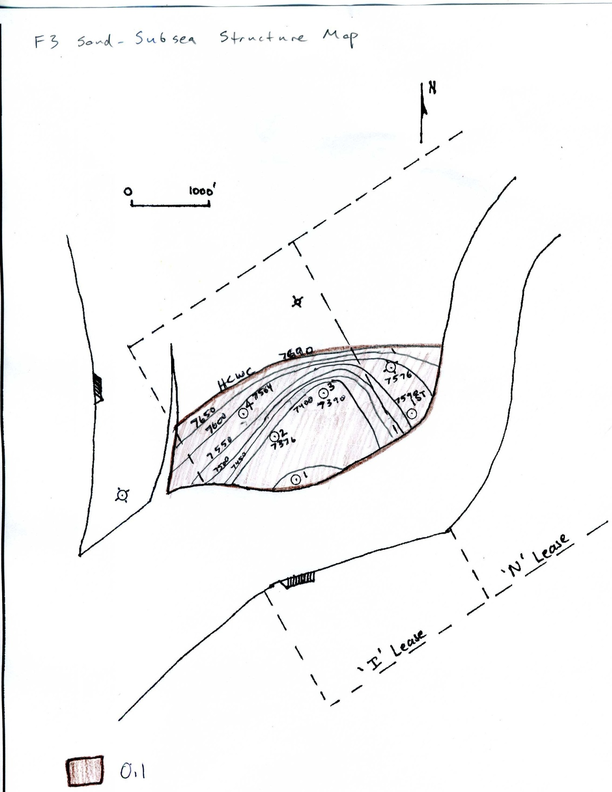

**Figure 4.3**: F3 sand structure map

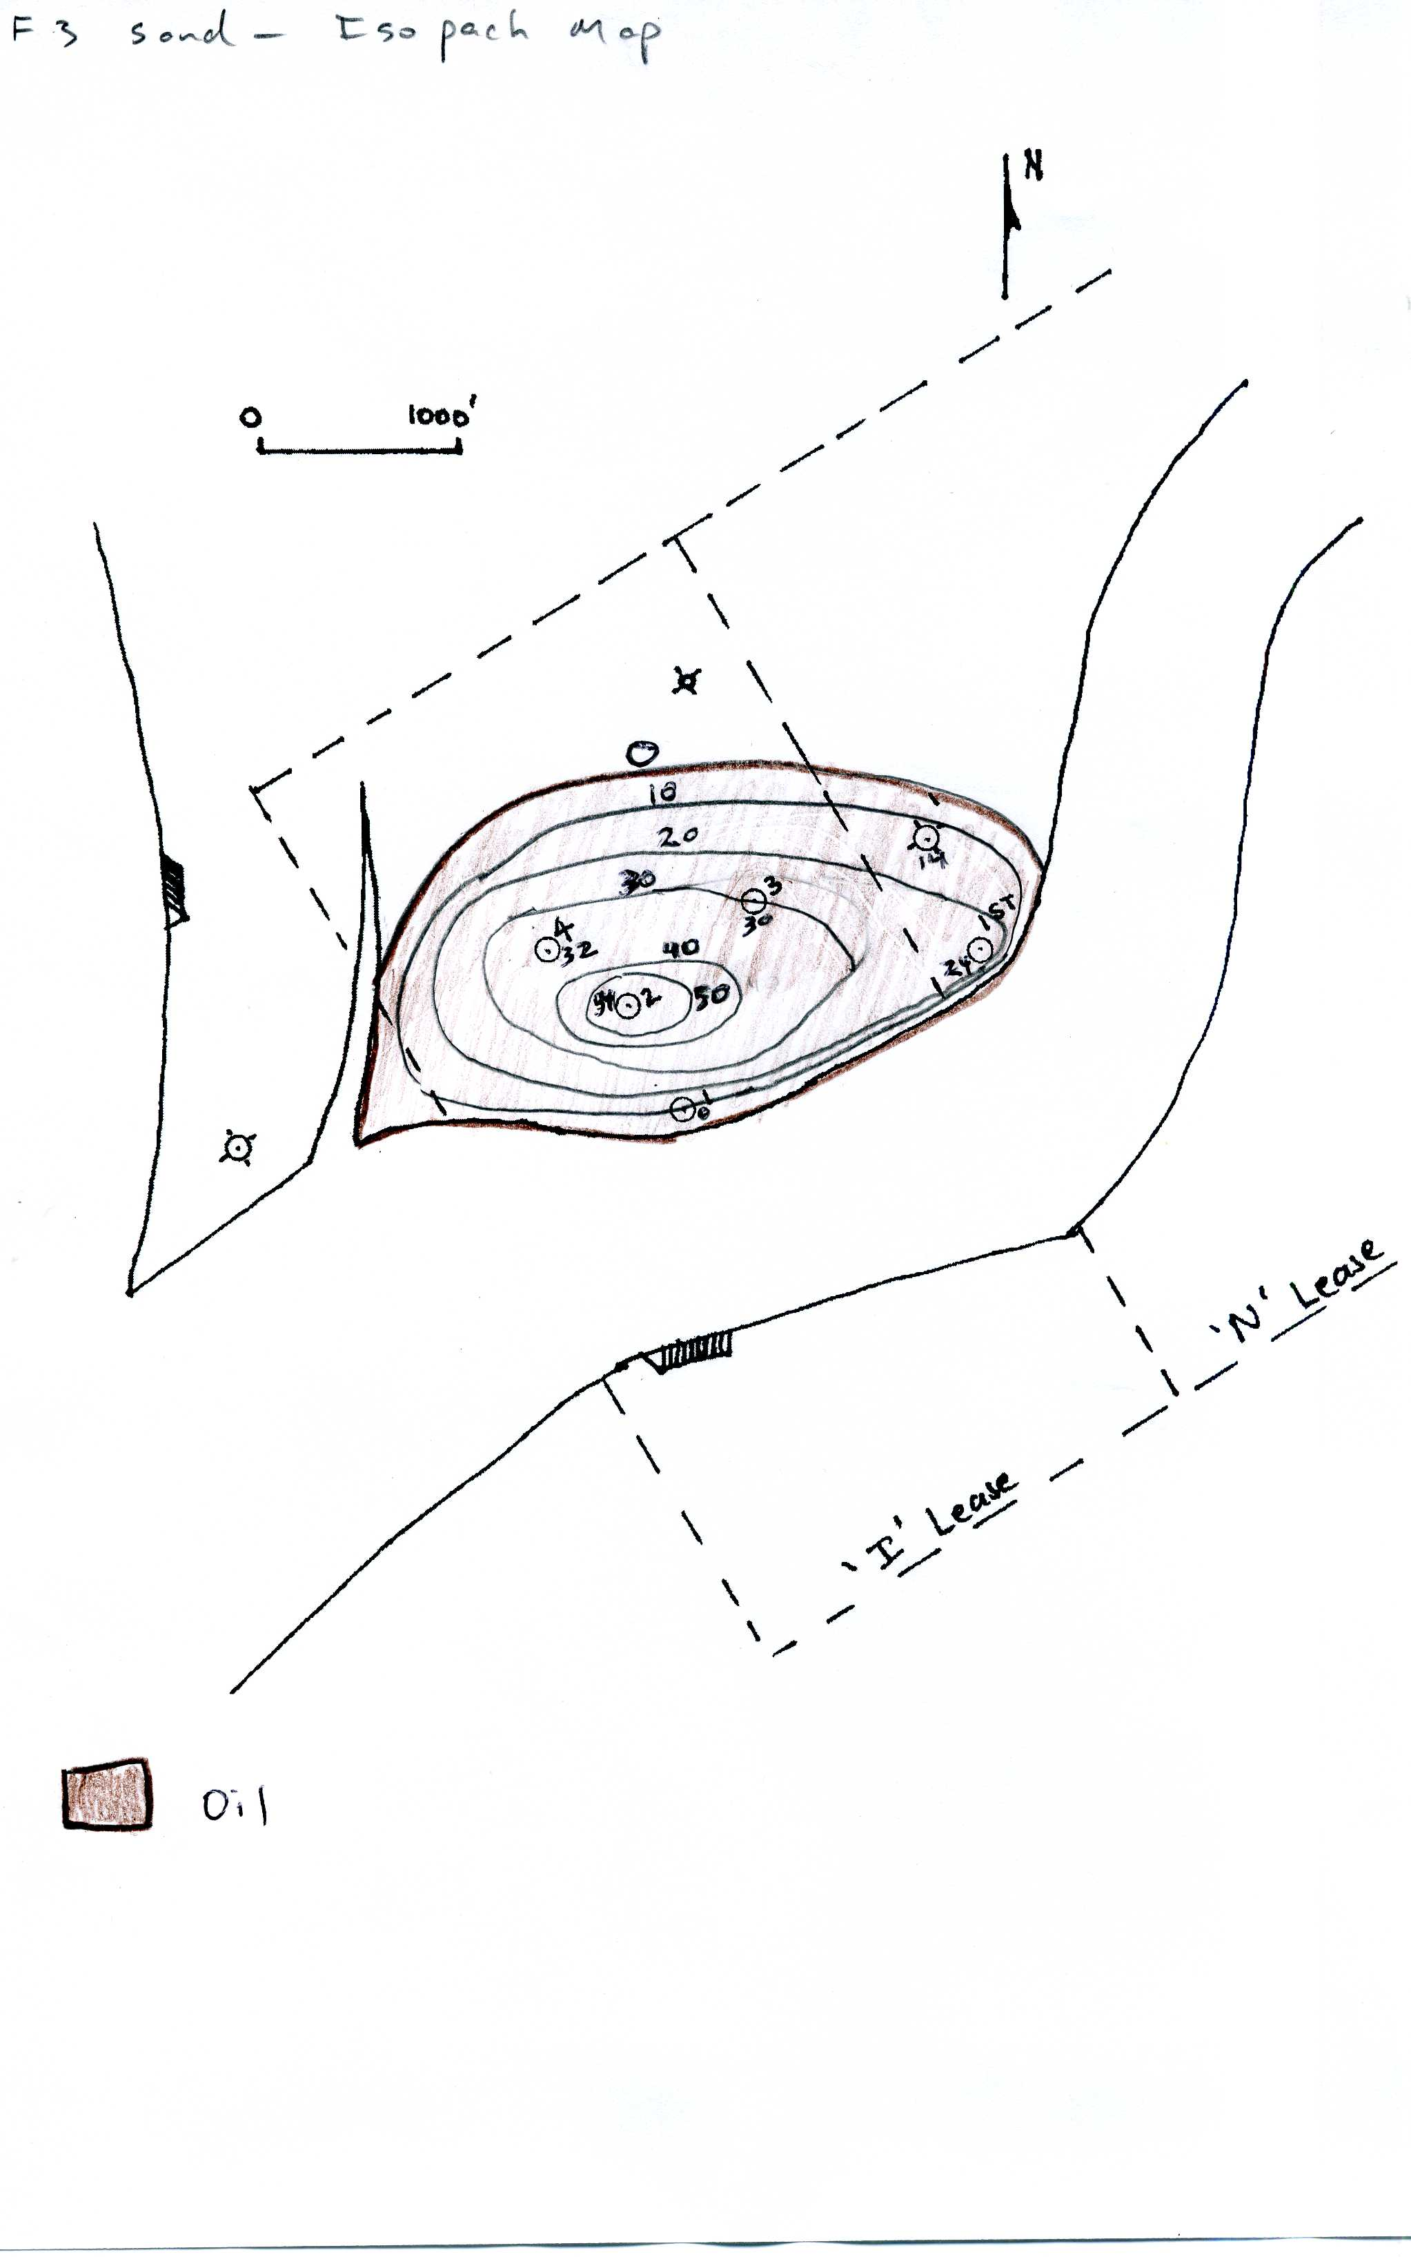

**Figure 4.4**: F3 sand isopach map

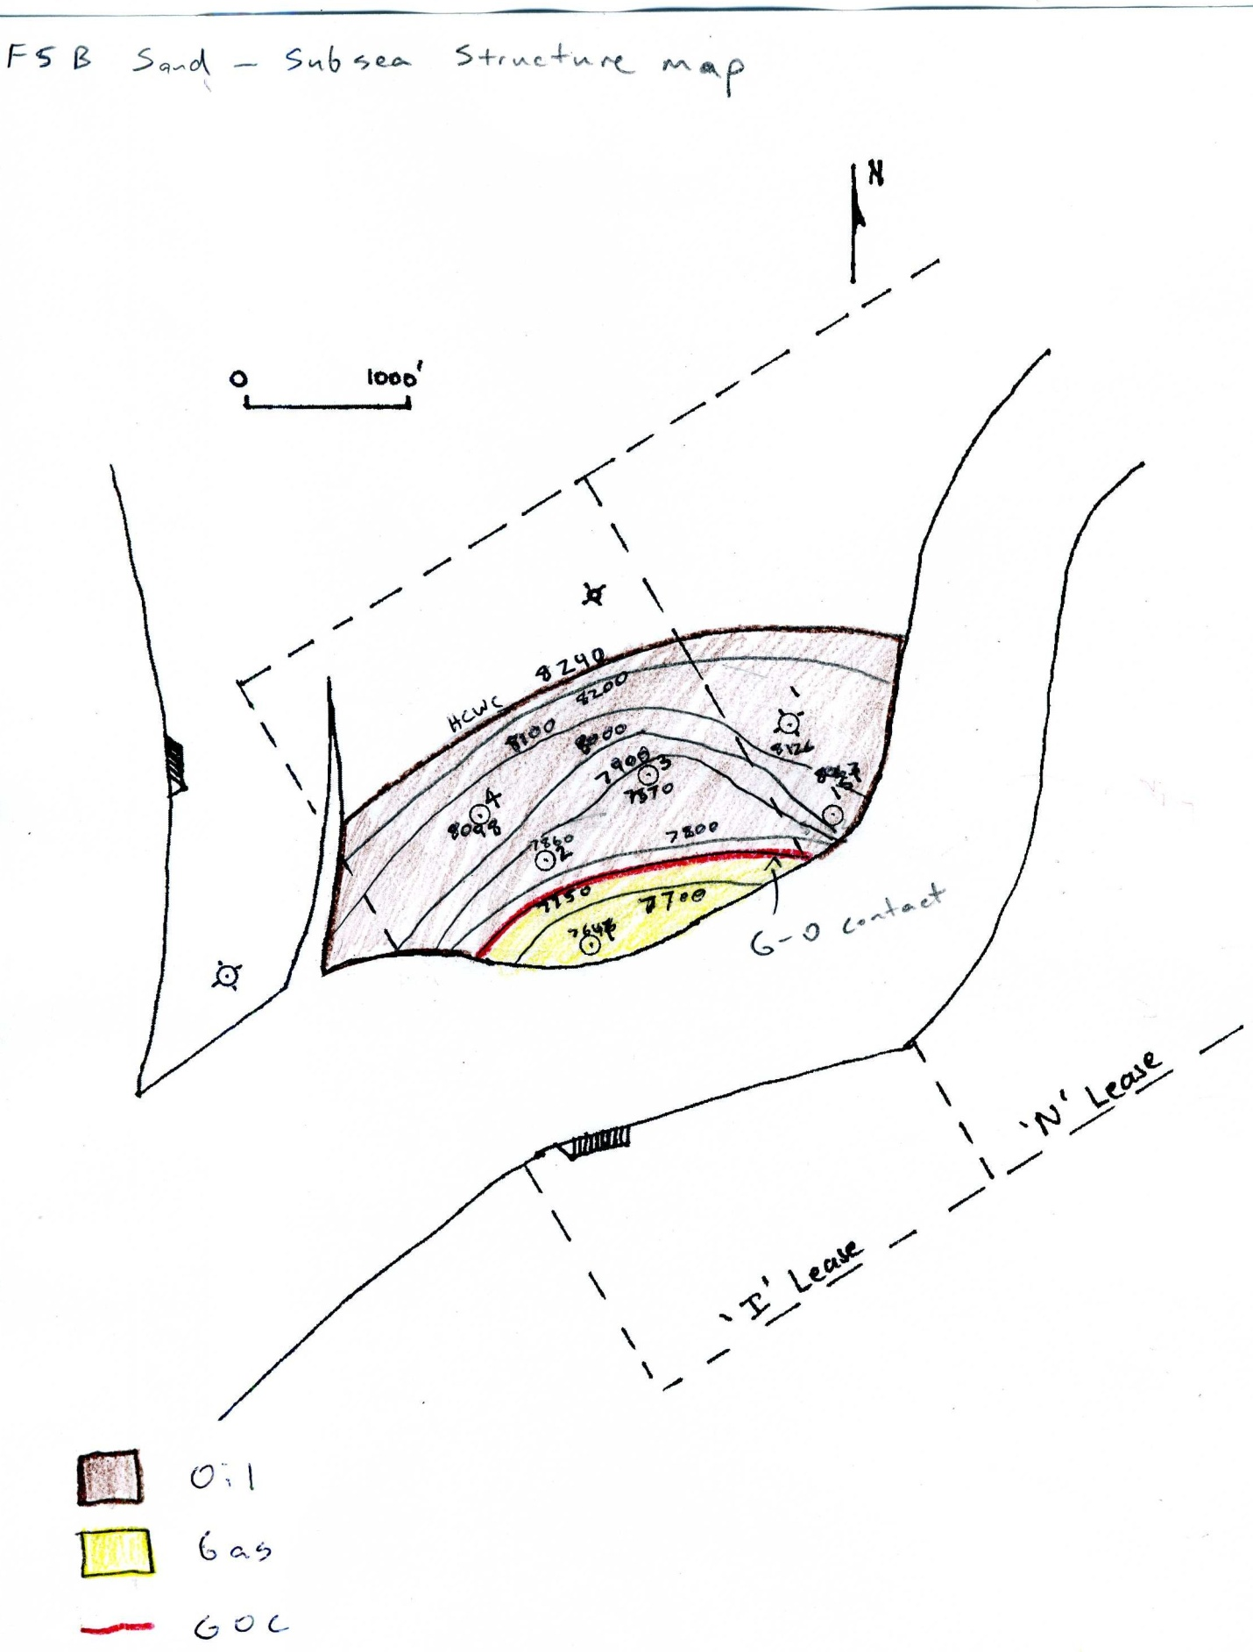

**Figure 4.5**: F5B structure map

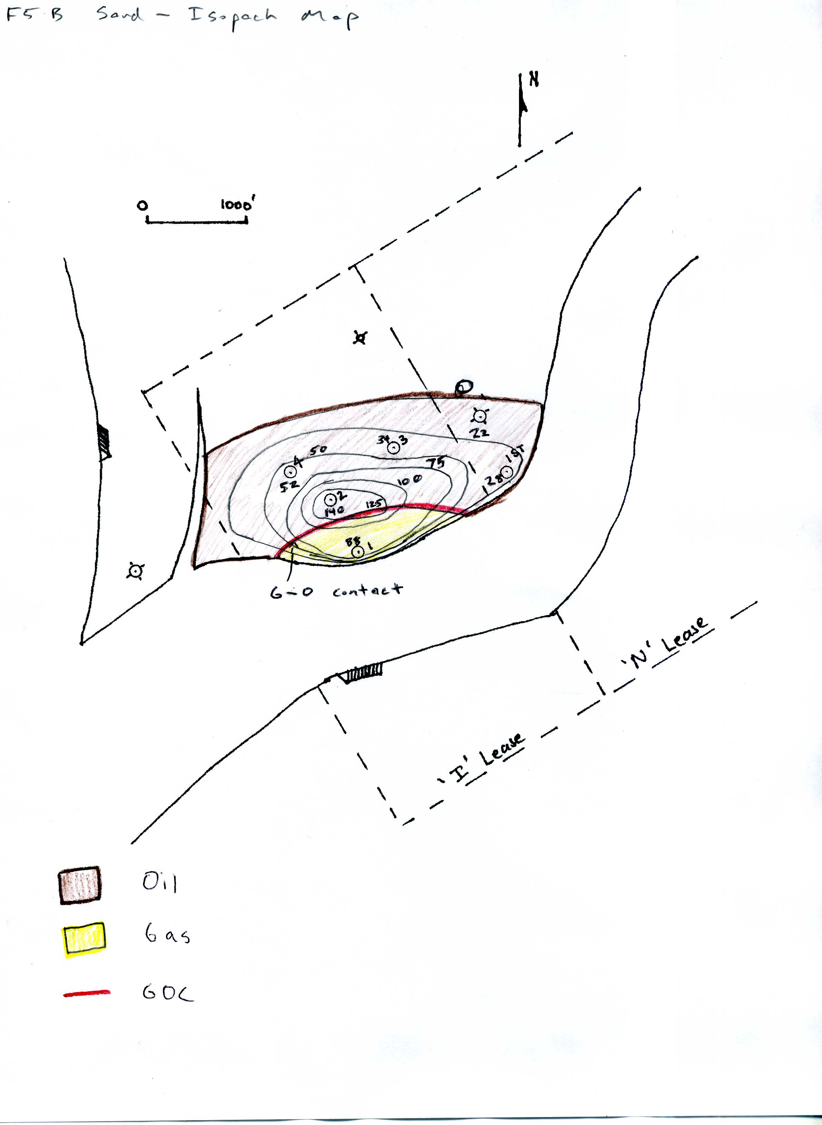

**Figure 4.6**: F5B isopach map

**Material Balance**

Using production data, PVT data, and well logs, we performed a material balance to estimate the total oil and gas in place in the F3 and F5B reservoirs. This was simpler to do in the F3, as it did not have an aquifer or a gas cap, whereas the F5B had both. As expected, the F3, with just a solution gas drive, showed a lower recovery factor than the F5B. This section details how the volumetric estimates were made using a material balance. The equations presented in this section are from Walsh and Lake (2003).

The first step in the material balance was calculating the net fluid withdrawal, F, from the reservoir. This is a function of the cumulative oil, water, and gas production and the PVT data and was calculated from equation 4.11 below.

$F=G_{ps}\left(\frac{B_{g}-B_{0}R_{v}}{1-R_{v}R_{s}}\right)+N_{p}\left(\frac{B_{o}-B_{g}R_{s}}{1-R_{v}R_{s}}\right)+(W_{p}-W_{I})B_{w}$ (4.11)

Gps = Cumulative produced sales gas (non-injected) (MSCF)

Np = Cumulative oil produced (STB)

Wp = Cumulative water produced (STB)

WI = Cumulative water injected (STB; zero in this case)

Bg = Gas formation volume factor (Res bbls/MSCF)

Bo = Oil formation volume factor (Res bbls/STB)

Bw = Water formation volume factor (Res bbls/STB; assumed to be 1.00)

Rv = Volatilized gas/oil ratio (Res bbls/MMSCF)

Rs = Solution gas/oil ratio (SCF/STB)

Next, we calculated the two phase oil and two phase gas formation volume factors, shown in Equations 4.12 and 4.13 below.

$B_{to}=\frac{B_{o}\left(1-R_{si}R_{v}\right)+B_{g}(R_{si}-R_{s})}{1-R_{s}R_{v}}$ (Res bbls/STB) (4.12)

$B_{tg}=\frac{B_{g}\left(1-R_{vi}R_{s}\right)+B_{o}(R_{vi}-R_{v})}{1-R_{s}R_{v}}$ (Res bbls/SCF) (4.13)

These are then used in the calculation of the oil (Eo) and gas (Eg) expansivities, Equations 4.14 and 4.15. The water expansivity is calculated using the water formation volume factor, shown in Equation 4.16.

$E_{o}=B_{to}-B_{toi}$ (Res bbls/STB) (4.14)

$E_{g}=B_{tg}-B_{tgi}$ (Res bbls/SCF) (4.15)

$E_{w}=B_{w}-B_{wi}$ (Res bbls/STB) (4.16)

The pore volume expansivity, Ef, is measured in rock compressibility tests. In our case, we assumed the values were similar to an example reservoir given by Walsh and Lake (2003). The composite oil/water/rock expansivity (Eowf) and gas/water/rock expansivity (Egwf) are then calculated using these expansivities, shown in Equations 4.17 and 4.18.

$E_{owf}=E_{o}+\frac{B_{oi}}{\left(1-S_{wi}\right)}(\frac{S_{wi}E_{w}}{B_{wi}}+E_{f})$ (Res bbl/STB) (4.17)

$E_{gwf}=E_{g}+\frac{B_{gi}}{\left(1-S_{wi}\right)}(\frac{S_{wi}E_{w}}{B_{wi}}+E_{f})$ (Res bbl/SCF) (4.18)

Swi = Initial average water saturation in the reservoir

Finally, we calculated the total expansivity, Et.

(Res bbl/STB) (4.19)

where m is the dimensionless ratio of the initial volumes of gas in place to oil in place, given by

$m=\frac{G_{fgi}B_{gi}}{N_{foi}B_{oi}}$ (4.20)

Gfgi = Surface volume of gas in the initial free-gas phase (MSCF)

Nfoi = Surface volume of oil in the initial free-oil phase (STB)

The final variable needed for the material balance is the water influx, We. This can be calculated if the size of the aquifer present is known. Because we do not have a good estimate for the aquifer size present below the F5B reservoir (no aquifer is present below the F3), We was estimated based on the plot of F-We vs. Et, with a linear slope desired. The slope of this graph is the initial volume of oil in place in the reservoir, Nfoi. Our plots of F-We vs. Et are shown in Figures 4.7 and 4.8 below.

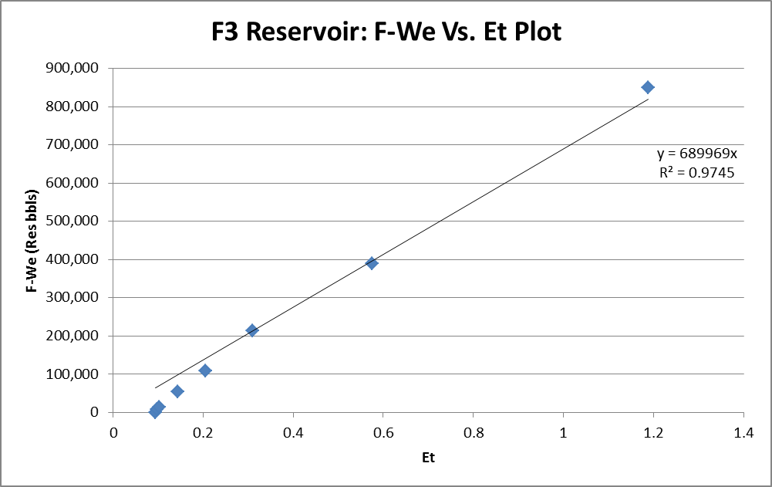

**Figure 4.7:** Plot of F-We vs. Et for the F3 reservoir

Because the F3 reservoir is simply a solution gas drive with no aquifer or gas cap initially present, we assume that both m and We are equal to zero. As seen in the figure above, the slope of the F-We vs. Et in the F3 is roughly equal to 700,000 STB. This is the predicted value of original oil in place for the F3 reservoir. Original gas in place is assumed to be zero, as we see no evidence of a gas cap in the F3.

**Figure 4.8**: F-We vs. Et plot for the F5B reservoir

The F5B reservoir has both an aquifer and a gas cap present. This tells us we must estimate both the water influx, We, and the ratio of gas in place to oil in place, m. To estimate We, we interpolated based on the knowledge that the plot of F-We vs. Et should be linear. This gave us a water influx of 900,000 bbls at our final point, where total fluid withdrawal, F, was nearly two million barrels. Our ratio of gas in place to oil in place, m, was estimated based on our volumetric analysis given earlier. The value of m that we chose, 0.6, is not the exact ratio from our volumetric analysis (roughly 0.8), but is fairly close and gives us estimates of oil and gas in place that are relatively similar to the values from the volumetric analysis. As seen from the plot above, the slope of the F-We vs. Et plot is roughly 1.3 million STB. This is the predicted value of original oil in place. Using our m value of 0.6, we then calculated a value of approximately 1.2 million MSCF of original gas in place. These volumes are compared to those from our volumetric analysis in the combined analysis section below.

**Combined Analysis**

Table 2 below summarizes the estimates of the initial oil and gas in place in the F3 and F5B sands for both the volumetric and material balance methods of estimation. The largest error between the two estimates is a 36% difference in the oil in place in the F3 reservoir. The estimates of oil and gas in the F5B are both within 20%. The difference in the estimates comes from a number of factors. Error in the material balance estimates can occur as a result of error in the PVT data, pressure data, and especially the production tests. There is also variability due to the large number of assumptions that go into the material balance such as the estimation of pore volume compressibility. Volumetric analysis also has the potential for significant error. There is a large amount of subjectivity in drawing structure and isopach maps with the limited data from the wells. We only have a good idea of the net thickness of the sands at the specific locations of the wells, and the gas-oil contact in the F5B is only known to occur between wells 1 and 2, but the specific location is unknown. All of these factors add up to a significant amount of uncertainty in our estimates. However, because the estimates are relatively close to each other, we can be fairly confident that they are in the correct neighborhood.

**Table 4.9**: Comparison of fluid in place estimates by two different methods

|  |  |  |  |  |  |  |
| --- | --- | --- | --- | --- | --- | --- |
|  | Oil in Place Estimate (MSTB) | | | Gas in Place Estimate (MMSCF) | | |
| Reservoir | Volumetric | Material Balance | Difference | Volumetric | Material Balance | Difference |
| F3 | 1,100 | 700 | 36% | N/A | N/A | N/A |
| F5B | 1,600 | 1,300 | 19% | 1,300 | 1,200 | 8% |

**5. PRODUCTION ANALYSIS**

We were given data for each well in each reservoir for approximately 60 months. During this time period we were able to compile all the data and try to determine a behavioral pattern of the wells. This is important in order to look into potential for artificial lift for any remaining hydrocarbons present.

**Figure 5.1**: F3 reservoir production history

Having compiled all production history from the F3 Reservoir, Well I-2 and Well I-3, we can start making estimates and predictions on future recovery. As we fit the most prevalent and recent data to a linear trend line we can determine that we could produce until 38 months. Therefore from where the oil production drops off (month 34) and where we can produce until (month 38) we can integrate from the line that we can produce approximately 5,400 more barrels of oil. Taking into account volumetrics from the material balance, our original oil in place is estimated to be roughly 700,000 STBO. Our current cumulative oil production is 173,000 STBO to date. This gives us a recovery factor of roughly 25%. This is quite low and therefore artificial lift should be considered. An example of a producing well from this reservoir is Well I-3. Figure 5.2 below shows its production history.

**Figure 5.2**: Well I-3 (F3 sand) production history

This well, if fit to a linear line, also shows that it could produce further. We calculate that it can produce to month 38. Between the month where production drops dramatically and this forecasted date we can integrate the fit line and find that we can produce about 2,200 STBO more. Taking into account oil prices at near $100, this artificial lift project could be quite profitable and at least something to consider. This would be the optimum well to attempt an artificial lift project, and if successful, could encourage attempting to artificially lift in other wells as well.

**Figure 5.3**: F5 production history

**Figure 5.4**: F5 production history: oil only

Looking at the oil production for the F5 Reservoir we can see that the trend line goes to zero around the time our production history ends. When we try to forecast this line it ends at 59 months, just before the end of production history at 60 months.

**Figure 5.5**: Well I-3L (F5 sand) production history

This does not necessarily mean that there is no more oil to be produced. However, when we take into account the recovery factor which is approximately 37%, which is reasonable for this type of reservoir; we can conclude that secondary recovery efforts may be futile. When we look at the overall performance of each well, see that Well I No. 4 is the lowest percentage of the recovery. This is due to it being at the edge of the reservoir. However, Well I No. 4 is not a waste; in the future we plan on using this well for water injection to possibly further drive production.

**6. Reservoir Analysis**

There are four different reservoirs that are productive in various parts of our field, the F3, F4, F5B and F5D. The two most productive are the F3 and F5B.

**F3 Reservoir**

The F3 reservoir is only present in Well I-2 and Well I-3. Well logs show that the F3 sits on top of a large shale layer, with no oil water contact visible. This tells us that there is no aquifer present below the reservoir, and any water production comes from connate water in the reservoir. This is confirmed by the fact that water production from this reservoir was minimal, with only 16,000 bbls produced through the life of the field. Well logs also indicate that there is no gas cap present. There is no density/neutron crossover on the logs, a strong indicator that the reservoir is all oil. Production data supports this assumption, as initial production is primarily oil, with an increase in gas production coming as reservoir pressure dropped later in the life of the field. The lack of both an aquifer and a gas cap, combined with the increase in gas production as pressure dropped, indicates that the reservoir is primarily a solution gas drive. Our estimated recovery factor for this reservoir, between 15 and 25 percent based on volumetric analysis and material balance, is on par with what is expected from a solution gas drive.

**F5B Reservoir**

The F5B is the largest of the four reservoirs in the field and is present in each of the productive wells. There is a large aquifer below the reservoir that provides pressure support. Production data shows a large spike in water production late in the life of the field as pressure decreases and the water influx from the aquifer is great enough to reach the perforations in our wells. A substantial gas cap is also present in the F5B. The clearest evidence of this is the production of mostly gas for the first three months in the life of Well I-1, before it was realized that oil was present below the gas. With both aquifer support and a gas cap drive, we expect a higher recovery factor from this reservoir than the F3. This is confirmed by our recovery factors estimated by volumetric analysis and material balance, roughly 30 to 35 percent.

**F4 / F5D Reservoirs**

The F4 and F5D sands are substantially smaller than the previous two discussed. We do not have specific production or pressure data for either of these reservoirs, making analysis difficult. However, we can determine from the logs that the F4 is primarily a gas sand and the F5D is an oil sand.

**Enhanced Recovery**

We did not deem a substantial enhanced recovery project to be economically feasible. There is simply not enough recoverable oil left in place to warrant drilling additional wells for injection. However, we do intend to convert Well I-4 into a water injection well because the cost of injecting water, $0.75/bbl, is significantly cheaper than the cost of trucking the produced water, $2.00/bbl. This well is by far the least productive of the wells we have drilled, so we will not lose substantial production by converting it. It is also located down dip of the remaining wells, making it a good candidate for injection. We plan to inject into the F3 reservoir for two reasons. One, it is the shallowest of our productive reservoirs, meaning it will require less horsepower from our pump to inject into. Second, the F5 sand already has aquifer support, helping it maintain pressure, while the F3 has no aquifer support. While injecting only our produced water will not completely maintain the pressure in the reservoir, it will slow the pressure decline.

**7. FACILITIES**

The schematic for the facilities layout is shown in Figure 7.1.

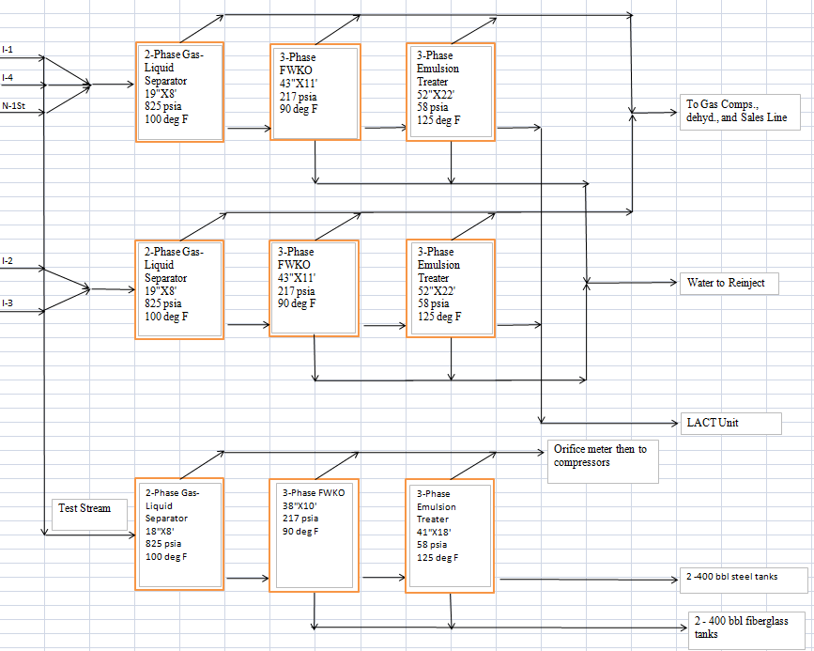

**Figure 7.1**: Facilities schematic

The initial separator pressure was chosen to be 825 psia so that the gas liberated could flow into the sales line without the need to be compressed by a compressor. The reservoir pressure stays above the 825 psia separator entrance pressure for some time. After the reservoir pressure drops below 825 psia the separator pressure will have to be reduced. This reduction in pressure will reduce the capacity of the separator, but the separator sizes are large enough to account for this. The three phase free water knock out (FWKO) separator will be operated at 217 psia, and the 3 phase emulsion treaters will be operated at 58 psia. The oil stock tanks will operate at 15 psia. The pressures were chosen by using Equation 7.01 where pi is 825 psia and ps is 15 psia.



(7.01)

Before we were able to calculate the separator sizes a flash calculation was conducted. The results for the first separator are shown in Table 7.1.

**Table 7.1**: First separator flash calculations

|  |  |  |  |  |  |  |
| --- | --- | --- | --- | --- | --- | --- |
| 2 Phase Separator |  |  |  |  |  |  |
| 825 psia |  |  |  |  |  |  |
| 100 deg F |  |  |  |  |  |  |
|  |  |  |  |  |  |  |
| Gas |  |  |  | Oil |  |  |
| MW = | 18.26893 | lb/molw |  | MW = | 128.3151 | lb/mole |
| S.G = | 0.629963 |  |  | S.G = | 0.759858 |  |
| Density = | 0.048129 | lb/scf |  | Density = | 47.41513 |  |
|  |  |  |  | API Gravity | 54.71905 | Deg API |
|  |  |  |  |  |  |  |
| Dry Heating Value | 1098.202 | BTU/SCF |  | Efficiency | 1.448639 | STBO/bbl |
| Wet Heating Value | 1078.983 | BTU/SCF |  |  |  |  |
| Gas Oil Ratio | 566.9183 | SCF/STBO |  |  |  |  |

The results for the second separator are shown in Table 7.2.

**Table 7.2**: Second separator flash calculations

|  |  |  |  |  |  |  |
| --- | --- | --- | --- | --- | --- | --- |
| 3-Phase FWKO |  |  |  |  |  |  |
| Pressure (psia) | 217 |  |  |  |  |  |
| Temperature(⁰F) | 90 |  |  |  |  |  |
|  |  |  |  |  |  |  |
| Gas |  |  |  | Oil |  |  |
| MW = | 20.54927 | lb/molw |  | MW = | 153.3925 | lb/mole |
| S.G = | 0.708595 |  |  | S.G = | 0.789622 |  |
| Density = | 0.054137 | lb/scf |  | Density = | 49.2724 |  |
|  |  |  |  | API Gravity | 47.69972 | Deg API |
|  |  |  |  |  |  |  |
| Dry Heating Value | 1206.863 | BTU/SCF |  | Efficiency | 0.527021 | STBO/bbl |
| Wet Heating Value | 1185.743 | BTU/SCF |  |  |  |  |
| Gas Oil Ratio | 180.9916 | SCF/STBO |  |  |  |  |

The results of the three phase emulsion separator are shown in Table 7.3.

**Table 7.3**: Three phase emulsion separator flash calculations

|  |  |  |  |  |  |  |
| --- | --- | --- | --- | --- | --- | --- |
| 3-Phase Emulsion |  |  |  |  |  |  |
| Pressure (psia) | 58 |  |  |  |  |  |
| Temperature(⁰F) | 125 |  |  |  |  |  |
|  |  |  |  |  |  |  |
| Gas |  |  |  | Oil |  |  |
| MW = | 33.64099 | lb/molw |  | MW = | 165.4757 | lb/mole |
| S.G = | 1.160034 |  |  | S.G = | 0.802611 |  |
| Density = | 0.088627 | lb/scf |  | Density = | 50.08291 |  |
|  |  |  |  | API Gravity | 44.79968 | Deg API |
|  |  |  |  |  |  |  |
| Dry Heating Value | 1807.324 | BTU/SCF |  | Efficiency | 0.45106 | STBO/bbl |
| Wet Heating Value | 1775.695 | BTU/SCF |  |  |  |  |
| Gas Oil Ratio | 73.94579 | SCF/STBO |  |  |  |  |

The results of the stock tank flash calculations are shown in Table 7.4.

**Table 7.4**: Stock tank flash calculation results

|  |  |  |  |  |  |  |
| --- | --- | --- | --- | --- | --- | --- |
| Stock Tank |  |  |  |  |  |  |
| Pressure (psia) | 15 |  |  |  |  |  |
| Temperature(⁰F) | 80 |  |  |  |  |  |
|  |  |  |  |  |  |  |
| Gas |  |  |  | Oil |  |  |
| MW = | 46.96412 | lb/molw |  | MW = | 170.234 | lb/mole |
| S.G = | 1.619453 |  |  | S.G = | 0.807691 |  |
| Density = | 0.123726 | lb/scf |  | Density = | 50.39989 |  |
|  |  |  |  | API Gravity | 43.69084 | Deg API |
|  |  |  |  |  |  |  |
| Dry Heating Value | 2410.962 | BTU/SCF |  | Efficiency | 0.70843 | STBO/bbl |
| Wet Heating Value | 2368.77 | BTU/SCF |  |  |  |  |
| Gas Oil Ratio | 28.78225 | SCF/STBO |  |  |  |  |

The resulting emissions are shown in Table 7.5.

**Table 7.5**: Emissions

|  |  |  |  |  |
| --- | --- | --- | --- | --- |
| Emissions |  |  |  |  |
| Pressure (psia) | 15 | Oil Rate | 1464 | STB/Day |
| Temperature(⁰F) | 80 |  |  |  |
|  | Data | Mass Rate |  |  |
| Component, n | Mole % | Tons/year |  |  |
| N2 | 2.92E-05 | 0.004226 |  |  |
| C02 | 0.041514 | 7.765539 |  |  |
| H2S | 0 | 0 |  |  |
| C1 | 0.590228 | 45.68631 |  |  |
| C2 | 1.910266 | 183.2045 |  |  |
| C3 | 4.00855 | 263.96 |  |  |
| iC4 | 1.976224 | 83.89468 |  |  |
| nC4 | 2.701466 | 86.87337 |  |  |
| iC5 | 2.051049 | 37.38236 |  |  |
| nC5 | 2.297902 | 32.862 |  |  |
| C6 | 3.119926 | 22.10931 |  |  |
| C7 + | 81.30285 | 187.7171 |  |  |
| Total VOC |  | 714.7988 |  |  |
| Total GHG |  | 236.6563 |  |  |

After calculating the emissions it was concluded that the emissions were above the legal limit to vent to the atmosphere, meaning that all gases would have to be trapped and disposed of properly. This is accomplished by compressing the gas and re-injecting it into the sales line. The size of the two phase separator was calculated by choosing the larger of the gas velocity constraint and the liquid retention time constraint dimensions using Equations 7.01 through 7.08.

Gas Velocity Constraint:









Liquid Retention Time Constraint:



Where



All of the fluid properties were taken from the PVT data or from the flash calculations. The FWKO separator size was determined by using the liquid time constraint, Equations 7.07 to 7.08. A FWKO separator was deemed necessary because of the significant volumes of water produced. A settling time check was conducted to ensure proper sizing. The emulsion treater was sized using Equations 7.07 to 7.08 as well. Here tl was assumed to be 30 minutes because no lab data was available so a worst case scenario was assumed. The stock tanks available to us are 400 bbl steel tanks. Steel was chosen because of its robustness and its ability to dissipate a static charge. This helps to avoid blowing the tanks up. The tanks are set on grade bands to avoid water corrosion. At our production levels a LACT unit was deemed necessary because our maximum flow rates were over 1000 bbls/day which is the normal cutoff. The LACT unit will be able to measure oil production volumes. At later production rates three 400 bbl storage tanks are necessary if we wish to sell the LACT unit. The production stream will be split into two groups by production volumes. Group 1 will consist of wells I-1, I-4, and N1-ST. Group 2 will consist of wells I-2, and I-3. Both groups of wells produce approximately equivalent volumes. A separate set of test separators will be able to process an individual well. This allows us to test the performance of an individual well. The sizes of the test separator are shown in Figure 7.1. The oil and water volumes will be measured directly by the LACT unit while the gas flow rate will be measured by an orifice meter. The meter will be placed directly upstream of the sales line tie-in. All of the gas released by the separators will be compressed and sent into the sales line. After compression and prior to entry into the sales line the gas will go through a dehydrator. The dehydrator will ensure meeting the gas quality standards of 7 lb of water per MMSCF of gas. A graph of dehydrator diameter and fuel requirement vs. pressure is shown in Figure 7.2.

**Figure 7.2**: Dehydrator diameter and fuel requirements vs pressure

There will be three compressors each operating at two stages. The summary of the compression is shown in Table 7.6. The first compressor will raise the pressure from 15 psia to 58 psia, the second compressor will boost the pressure from 58 psia to 217 psia, and the last compressor will raise the pressure from 217 psia to 817 psia. The total horsepower needed for compression is 48hp/day which equates to almost $29,000/month. To avoid the formation of gas hydrates, line heaters will be employed directly downstream of the chokes. Since so much water is produced trucking the water away was not economical. We decided to re-inject the water into well I-4 in the F-3 zone. This limits the amount of processing the water needs to be disposed of legally.

**Table 7.6:** Summary of compressors

|  |  |  |  |  |  |  |  |
| --- | --- | --- | --- | --- | --- | --- | --- |
| Compressor 1 |  |  |  |  |  |  |  |
|  |  |  |  |  |  |  | Stage Power |
| Stage | Ps(psia) | Pd(psia) | Ts (deg F) | z | cp | k | (hp/MMScf/day) |
| 1 | 15 | 29 | 80 | 0.99 | 22.57483 | 1.096673 | 1.65 |
| 2 | 29.4 | 58 | 80 | 0.99 | 22.57483 | 1.096673 | 1.66 |
|  |  |  |  |  |  | Total | 3.31 |
|  |  |  |  |  |  |  |  |
| Compressor 2 |  |  |  |  |  |  |  |
|  |  |  |  |  |  |  | Stage Power |
| Stage | Ps(psia) | Pd(psia) | Ts (deg F) | z | cp | k | (hp/MMScf/day) |
| 1 | 58 | 112 | 120 | 0.98 | 16.76214 | 1.134713 | 6.13 |
| 2 | 112 | 217 | 120 | 0.97 | 16.76214 | 1.134713 | 6.10 |
|  |  |  |  |  |  | Total | 12.23 |
|  |  |  |  |  |  |  |  |
| Compressor 3 |  |  |  |  |  |  |  |
|  |  |  |  |  |  |  | Stage Power |
| Stage | Ps(psia) | Pd(psia) | Ts (deg F) | z | cp | k | (hp/MMScf/day) |
| 1 | 217 | 421 | 90 | 0.96 | 10.44592 | 1.235338 | 16.19 |
| 2 | 421 | 817 | 90 | 0.94 | 10.44592 | 1.235338 | 15.83 |
|  |  |  |  |  |  | Total | 32.02 |
|  |  |  |  |  |  |  |  |
|  |  |  |  |  |  | Total | 48 |
|  |  |  |  |  |  |  |  |
|  |  |  |  |  |  |  |  |
|  |  |  |  |  |  |  |  |
| Cost | $20/hp/mo |  |  |  |  | Total | $28,538.45 |
|  |  |  |  |  |  | Cost |  |

**8. ECONOMICS**

The economic analysis in this section is broken down into the analysis done prior to drilling Well I-1, and the analysis of the total field.

**Well I-1**

The costs of drilling and completing Well I-1 were tabulated using the company AFE form. This information was then used in analyzing the prospect using PHDWin.

AUTHORITY FOR EXPENDITURE (AFE)

The AFE presented in Figure 8.1 is for Well I-1, but will also be applied to each subsequent well. We analyzed local area drilling time curves and determined that the time required to drill and complete each well is about fifteen days and seven days, respectively. The survey, regulatory, and permits section of the AFE includes pipelines, surface site, wetland reports, and damages, among other things. Rig costs are broken down into mobilization, daywork, and completion. Bits and mills costs vary for the surface, intermediate, and production holes and include both bits and scrapers. Cementing accounts for 2365 sacks of cements. Casing crews and lay-down services take into account the costs for casing washing and preparation for each casing string, excluding the conductor casing. Transportation is the cost for miscellaneous trucking and pump truck rental. Well testing and inspection pays for BOP testing for initial installation and at intermediate points. The total intangible costs come to approximately $1,700,000.

Casing heads and well heads use 5000 psi well pressure, as mentioned in the Rig No. 10 specifications for rams, annular preventers, and choke manifold. Tankage accounts for 400 bbl steel tanks and 400 bbl fiberglass tanks. Treaters and separators include HP, 2 phase separator; LP, 3 phase separator; oil coalescers; LACT Units; and heaters treaters. Pumping equipment covers salt-water disposal pumps and transfer pumps. Flow lines/connections and telemetry are added in the Connections/Fittings/Miscellaneous section. The total tangible costs for the well are estimated to be just under $1,000,000. Figure 8.1 breaks down the estimated costs of the well, with the total cost estimated to be about $2,700,000.



**Figure 8.1**: Authority of Expenditure

ECONOMIC JUSTIFICATION FOR DRILLING

The spreadsheet in Figure 8.2 below summarizes the economic projections for Well I-1. A discount rate of 10% was used. Operating costs were set to escalate at 5% per year, beginning in year two. Futures prices as of January 1, 2011 for oil and gas were used for the first four years, with prices being held constant afterwards. Our working interest was 100% and net revenue interest was 75%. We assumed the entire $2.7 million for drilling costs occurred at the start of 2011. The predicted net present value of the well is just under $9 million, giving us a return on investment of roughly $4.30 for every $1.00 spent. This meets the company’s requirement of earning $3 for every $1 spent. The discounted rate of return is roughly 93%, well above the required 25% to justify the project. The project pays out at some point in year two, under the 24 month maximum payout period set forth. Figure 8.3 shows the same data, but with a price deck of $3.50 for gas. The project is still clearly positive under these conditions, meeting the final requirement to go forward with the well.

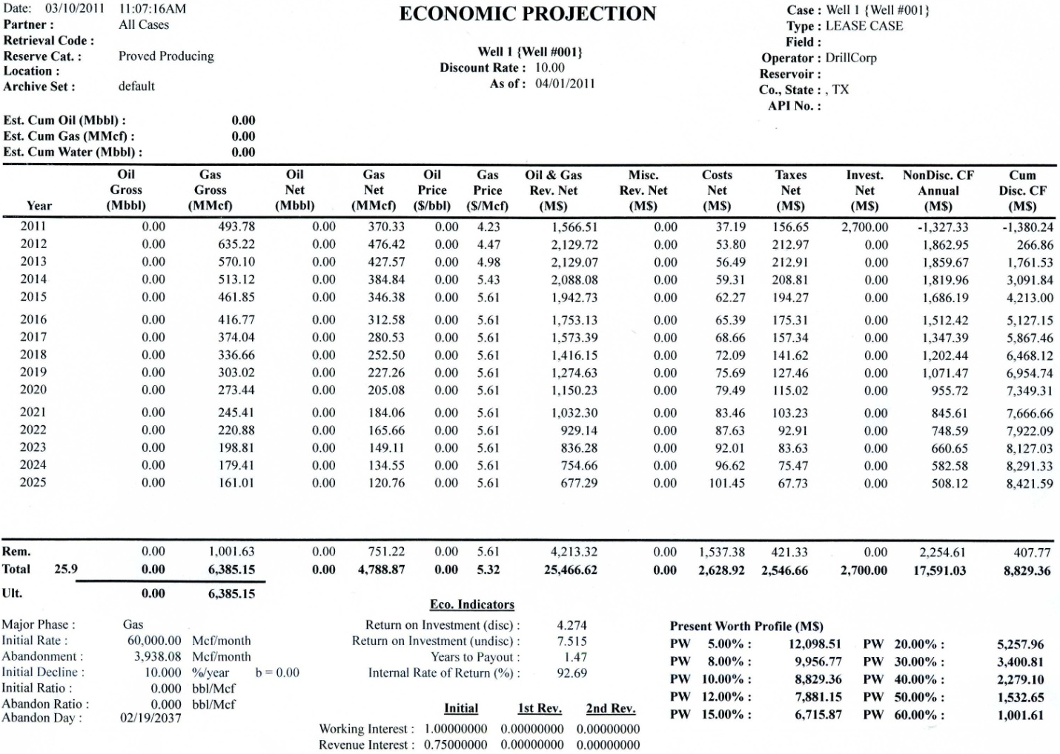

**Figure 8.2**: Well I-1 economic projection

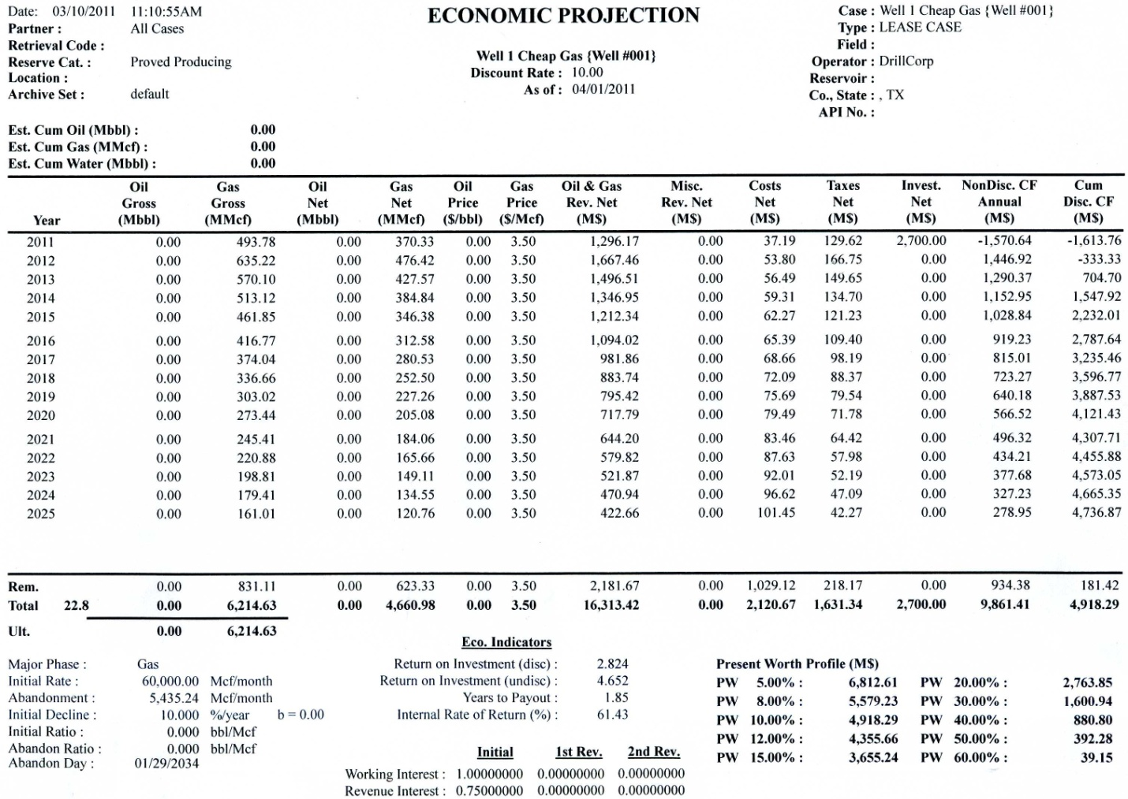

**Figure 8.3**: Well I-1 economic projection, gas price = $3.50

**Overall Project Economics**

This analysis was performed after the drilling of all six wells in the field. Parameters such as discount rate, prices, etc… are the same as for the projections of Well I-1. Wells I-2 and I-3, the two wells with production from the F3 reservoir, were treated as two separate wells, with the costs divided equally between the F3 well and F5B well. The costs for each well were assumed the same as for Well I-1. Facilities costs were input as a separate case, with all facilities costs occurring at the beginning of the project. Compression costs, roughly $29,000 per month, were divided equally among all five productive wells. The production data we have to date was imported into PHDWin and extrapolated using a curve fit. The economic limit of the project was reached not long after the production data we have ends, as seen by the rapidly decreasing profits in the later years in Figure 8.4. Our total estimated discounted NPV was roughly $41.5 million. Using basement prices of $3.50/MCF gas and $42/bbl oil, we still get a positive NPV of just over $10 million (Figure 8.6), meeting the company requirement of a positive NPV against those price decks. We also have a rate of return of 186%, a payout period of less than two years, and a return of investment of over $4 profit to $1 spent, more than meeting all of our company’s standards to proceed with the project.

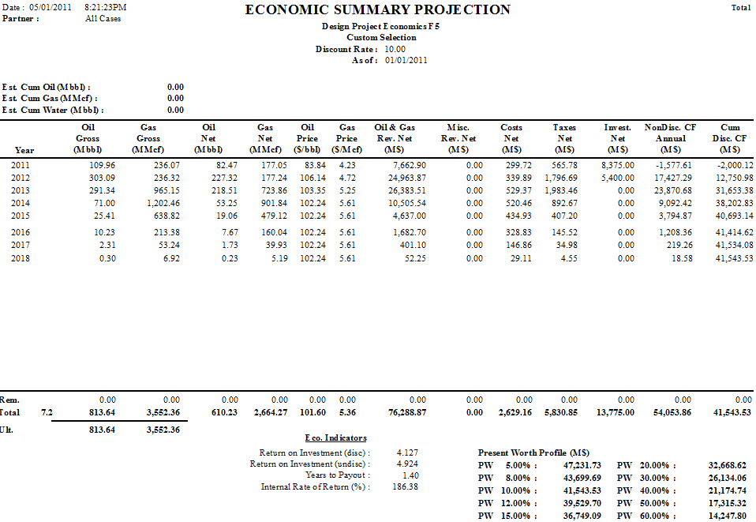

**Figure 8.4**: Cash flow from all wells combined

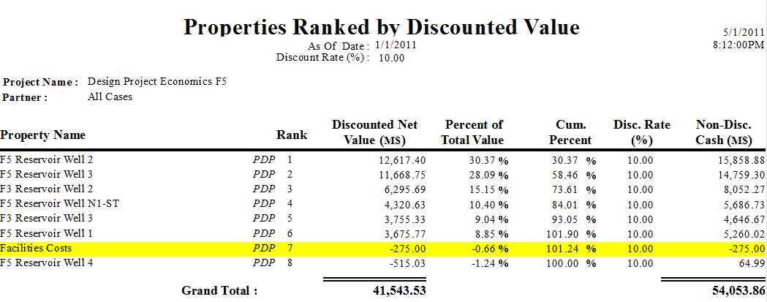

**Figure 8.5**: Ranking of wells according to discounted value (facilities included as individual case). Wells I-2 and I-3 were split by reservoir (F3 and F5).

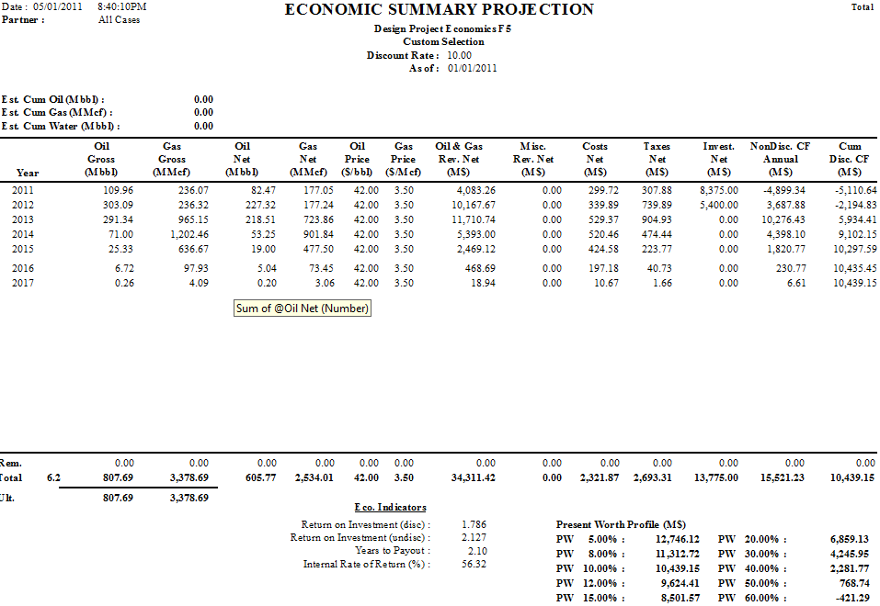

**Figure 8.6**: Overall project economics with $3.50/MCF gas and $42/bbl oil prices

**REFERENCES**

Bommer, Dr. Paul M. *Drilling and Well Completions Class*. 2009. University of Texas, Austin.

Bommer, Dr. Paul M. *Oil and Gas Production Facilities Design Class*. 2011. University of Texas, Austin.

Bommer, Dr. Paul M. *Production Technology and Design Class*. 2010. University of Texas, Austin.

Bourgoyne Jr., Adam T., Martin E. Chenevert, Keith K. Millheim, and F. S. Young Jr. *Applied Drilling Engineering Textbook: Volume 2.* United States: SOCIETY OF PETROLEUM ENGINEERS OF AIME (TX), 1991. Print.

*DrillingInfo*. 2011. Web. 01 Feb. 2011. <http://www.drillinginfo.com>.

"Pioneer Drilling - Drilling Service Rig Fleet." Pioneer Drilling Company. Web.   
01 May 2011. <http://www.pioneerdrlg.com/rig-fleet.aspx?id=1>.

*Texas Department of Transportation*. 2011. Web. 20 Feb. 2011. <http://www.txdot.gov>.

Torres-Verdin, Dr. Carlos. *Fundamentals of Well Logging Class*. 2010. University of Texas, Austin.

Walsh, Mark P., and Larry W. Lake. *A Generalized Approach to Primary Hydrocarbon Recovery*. Amsterdam: Elsevier, 2003. Print.